Preparation Activity

Data

- The daily minimum temperatures over a week at Orange were -4, 3, -6, 0, 5, -7 and -5. What was the average daily minimum temperature?

- Mr Benson wanted to collect data on Year 10’s favourite genre of television shows. What would the data be classified as (numerical continuous, numerical discrete, categorical ordinal, categorical nominal)?

- The stem-and-leaf-plot below shows the ages of twenty players in a football squad.

Stem | Leaf
1 | 7 8 9 9
2 | 0 2 4 5 6 6 8 8 8 9
3 | 0 0 1 1 2 3

Calculate the median age of the players.

- A second-hand bookstore has 5 books on the table. The modal price of these books is $8, the median price is $6 and the books have a range in price of $5. What is the price of the cheapest book on the table?

- A sports statistician wants to determine which of two players are the most consistent in their number of tackles. He counts the number of tackles by each player in each game for 20 weeks and finds the mean, mode, median, range and interquartile range for each player.

 | Player 1 | Player 2
Mean | 12 | 15.8
Median | 12 | 14
Mode | 23 | 12
Range | 18 | 17
IQR | 8.5 | 10

Which two measures could he use to compare consistency?

A Mean and Median
B Mean and Mode
C Mode and Interquartile range
D Range and Interquartile range

- This dot plot shows the number of children who live in each unit in a block of 20 units.

 | O
 | O | O
 | O | O | O
 | O | O | O | O
 | O | O | O | O
 | O | O | O | O | O | O
 | 0 | 1 | 2 | 3 | 4 | 5
Number of children

Describe the shape of this distribution.

- The heart rate of 28 students was taken after 10 minutes of light exercise. The results are displayed on a dot plot below.

Present this information in a grouped frequency table.

Score | Frequency
130 - 139
140 - 149
150-159
160-169

- (a) These dot plots show the results for a class of 15 students who sat tests A and B. Both sets of results have the same mean and range.

Which data set (i.e. A or B) would have the higher standard deviation?

(b) Calculate the standard deviation correct to 1 d.p for both A and B.

- Employees on a factory assembly line are timed as they assemble a particular product.
The results are below (in minutes).

14 16 18 18 18 19 20 23 24 24 27 28 31 32
35 35 37 37 37 38 39 39 40 43 46 46 48 54

- Complete a five number figure summary of the data.

- Calculate the interquartile range for this data.

- The two box plots below were compiled from research into the effects of sustained exercise on resting heart rate.

They show the heart rates for a group who were doing no extra exercise (Control Group) and a group which were following a sustained exercise program (Test Group).

(a) What was the interquartile range for the control group?

(b) Both the control group and test group had 80 participants. How many more participants had a heart rate over 84 bpm in the control group compared to the test group?

- A score was added to this set of scores: 13, 18, 20, 20, 22, 26. The new mean is now 19. What score was added?

- A data set has a mean of 60 and a standard deviation of 10. A score of 100 is added to the data set. This score becomes the highest score in the data set. Which of the following will increase? (There can be more than one correct answer).

A mean B Standard Deviation C Range D Interquartile range.

- The following back-to-back stem-and-leaf plot shows the typing speed in words per minute (wpm) of 30 Year 8 and Year 10 students.

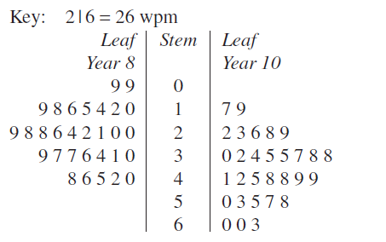

- Using a calculator or otherwise, construct a pair of parallel box-and-whisker plots to represent the two sets of data.

- Find the mean, median, range, interquartile range, and standard deviation of each set.

- Compare the two distributions, using your answers to parts (a) and (b).

- The following scatterplot shows the time (in weeks) spent by a person on a healthy diet and the corresponding mass lost (in kg).
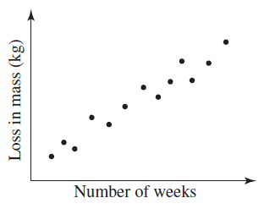

Determine if the following statements are true or false.

- The number of weeks that a person stays on a diet is the independent variable.

- The y-coordinates of the points represent the time spent by a person on a diet.

- There is evidence to suggest that the longer the person stays on a diet, the greater the loss in mass.

- The time spent on a diet is the only factor that contributes to the loss in mass.

- This scatterplot shows the recorded shadow length of a stick over a time period from noon to 4pm. 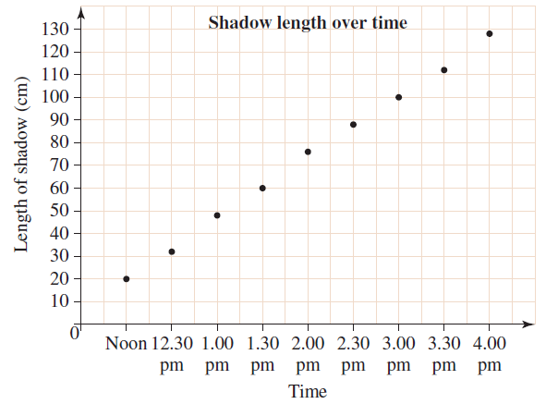
- Draw a line of best fit.
- Use your line of best fit to predict:
- The length of the shadow at 2:15pm
- The time when the shadow length would be 50 cm.
- The time when there is no shadow.

Expressions, Equations & Linear Relationships
- Simplify the following expressions:

- Factorise the following expressions. Simplify where appropriate.

- Solve the following equations.
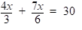

- 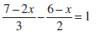

- Solve the following inequalities and graph the solution on a number line.

- $-5x+1≥26$

- Write the inequality which is represented on the number line below.

- Write the equation of the following lines.
(a)

(b) A line on the Cartesian plane has a gradient of and crosses the y axis 10 units below the origin.

(c) On a number plane, the straight line p, has a gradient of 4 and passes through the point (4, 9).

- A line crosses the x axis at (8, 0) and the y axis at (0, 4).

- A line on the Cartesian plane is parallel to the line and passes through the point

- The line are perpendicular and intersect at the point ( 3, 2).

- A straight line on a number plane has an equation of
What is the gradient of the line?

- Without drawing the line, show that the line passes through the point

- Graph the following linear equations.

- What is the solution to the simultaneous equations graphed below?

- Solve the following simultaneous equations using algebraic methods (either substitution or elimination method).

- Find the distance between the following pairs of points.
(a) (2,5) & (6,8)

(b) (-1,2) & (4,14)

(c) (-1,3) & (-7,-5)

- The distance between the points (3, b) and (-5, 2) is 10 units. Calculate the value of b.

- Prove that the points A(1, 1), B(3, -1) and C(-1, -3) are the vertices of an isosceles triangle.

- Use the formula method to find the coordinates of the midpoint of the line segment joining the following pairs of points.
(a) (-5,1) & (-1,-8)

(b) (4,2) & (11,-2)

(c) (0,4) & (-2,-2)

- Find the coordinates of the centre of a square with vertices A(0,0), B(2,4), C(6,2) and D(4,-2).

- Find the equation of a line that passes through the midpoint of A(-2,5) and B(-2,3) and has a gradient of -3.

Trigonometry

- Find the length of k in the right-angled triangle, correct to one decimal place.

- Find the length of the hypotenuse in the triangle, correct to one decimal place.

- Find the length of BC in the right-angled triangle, correct to one decimal place.

- Find the value of n, correct to the nearest cm.

- Find the value of, correct to the nearest degree.

- Find the size of correct to the nearest minute.

- What is the size of

- From the top deck of a lighthouse, Jessie measures the angle of depression of a yacht which is 160 m out to sea to be $55°$. How far is Jessie in a straight line from the yacht?

- Find the height of the tree (h), correct to the nearest 10th of a metre.

- A ship sails from B to C on a bearing of 260º for a distance of 465 km at which time it is due east of A.

How many kilometres is A south of B?

- Elvis hikes cross country from Motown (M) to Nashville (N) a distance of 20.3 km.

Orlean (O) is 15.2 km west of Motown and due south of Nashville.

What is the bearing of Nashville from Motown, correct to the nearest degree?

- A desktop of length 1.2 m and width 0.5 m rises to 10 cm. Calculate the size angle DBF, correct to the nearest minute.
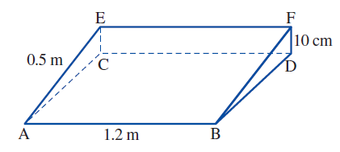

- In a right square-based pyramid, the length of the side of the base is 12 cm and the height is 26 cm.
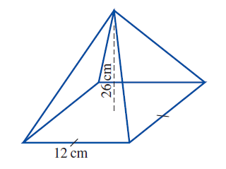
Determine the angle the triangular face makes with the base, correct to the nearest degree.

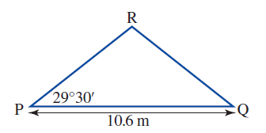
- A carpenter wants to make a roof pitched at $29°{30}^{'},$as shown in the diagram. How long should he cut the beam, PR? Round your answer correct to 2 decimal places.

- A boat sails on a compass direction of $E12°S$ for 10km then changes direction to $S27°E$ for another 20km. The boat then decides to return to its starting point.

- How far, correct to 2 decimal places, is the boat from its starting point?

- On what bearing should the boat travel to return to its starting point? Round your answer to the nearest degree.

- Two towers face each other separated by a distance, d, of 20 metres. As seen from the top of the first tower, the angle of depression of the second tower’s base is $59°$ and that of the top is $31°$. What is the height, in metres correct to 2 decimal places, of each of the towers?

Solutions

Data
- -2
- Categorical Nominal
- 27
- $3
- A
- Positively Skewed
Score | Frequency
130 - 139 | 5
140 - 149 | 10
150-159 | 7
160-169 | 6

- (a) Group A
(b) Group A - $σ_{x}=1.9$ Group B - $σ_{x}=1.3$

- (a) ${LE=14 Q}_{1}=21.5$ $Q_{2}=33.5$
$Q_{3}=39 UE=54$

(b) 17.5

- (a) 40
(b) 20

- 14

- A, B and C

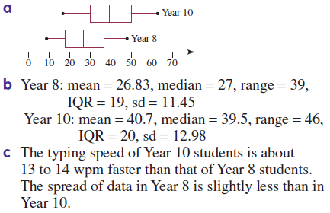

- (a) True
(b) False
(c) True
(d) False

- (a)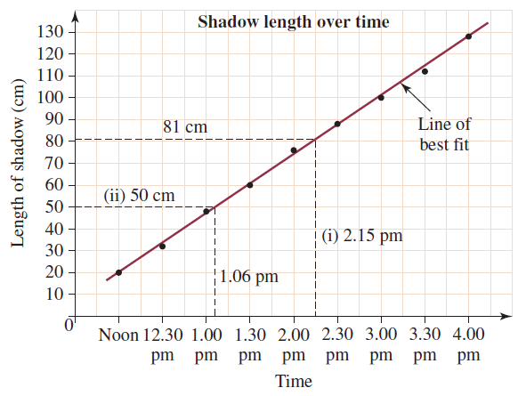
(b) i. 2:15pm ii. 50 cm
iii. A no time within the range of the data is there no
shadow.

Expressions, Equations & Linear Relationships
- (a) $-27a^{2}b^{2}c$
- $30p^{4}qr^{4}$
- $5w$
- $-\frac{6ac^{4}}{b^{3}}$
- $-10m+35$
- $30a^{2}-24ab$
- $16s^{3}t+8s^{2}t^{3}$
- $-2w-9$

- (a) $2p\left(p-6\right)$
- $4b^{2}c(2b^{2}c-3)$
- $5ab(7a-8+5a^{2}b^{2})$

- (a) $k=-6$
- $y=12$
- $p=8$
- $b=5$
- $r=-5$
- $x=12$
- $u=6$
- $x=11$
- $x=-10$

- (a) $x≥-\frac{4}{5}$
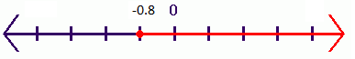
- $x<2$
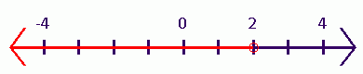
- $x≤-5$
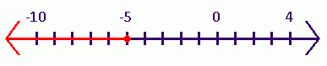

- $x≥-4$

- (a) $y=4x-8$
- $y=-5x-10$
- $p=4x-7$
- $y=-\frac{1}{2}x+4$
- $y=3x+20$
- $k=-\frac{1}{2}x+3.5$

- $Gradient (m)=-3$

- $-18+21-3=0$

- (a) 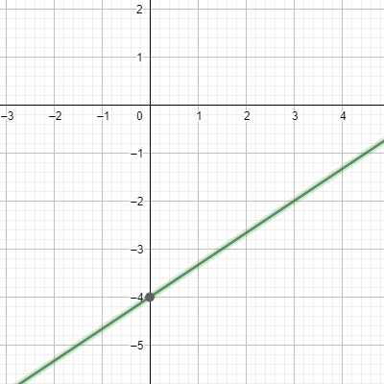

- 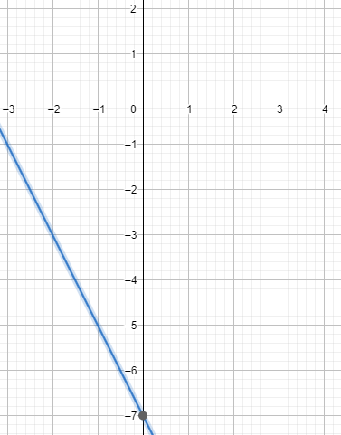

- 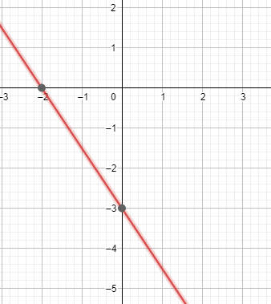

- 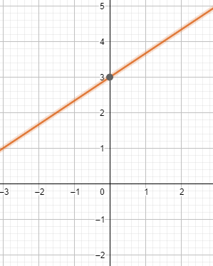

- $x=3, y=-2$

- (a) $x=1, y=3$
- $x=4, y=5$
- $x=2, y=1$
- $m=6, n=2$
- $p=-1, q=-5$
- $x=-4, y=-12$

- (a) 5
(b) 13
(c) 10

- b = -4

- AB = 2.83, AC = 4.47 & BC = 4.47
Since AC = BC, this is an isosceles triangle
(two sides equal length)

- (a) (-3,-3.5)
(b) (7.5,0)
(c) (-1,1)

- (3,1)

- $y=-3x-2$

Right-Angled Triangles

- $k=4.6 m$
- $23.9 m$
- $BC=22.3 m$
- $n=441.8 cm$
- $α=32°$
- $F=22°{37}^{'}$
- $T=27°$
- $279 m$
- $h=76.9 m$
- $80.7 km$
- $312°T$
- $DBF=11°32'$
- $77°$
- 6.09 m
- (a) 27.42 km (b) $317°T or N43°W$
- (a) 33.29 m (b) 21.27 m

