WATER IN THE CITY OF ORANGE | Name
Water use over a year

Collect the data for this page from the website below:
https://www.orange.nsw.gov.au/water/oranges-water-supply/

WATER USE – click on the “Orange’s Water Supply” tab in the blue bar. Fill out these tables.
MONTH | 2020 | 2021
JANUARY
FEBRUARY
MARCH
APRIL
MAY
JUNE
JULY
AUGUST
SEPTEMBER
OCTOBER
NOVEMBER
DECEMBER

DATE | CONSUMPTION
17 FEBRUARY 2022
03 MARCH 2022
17 MARCH 2022
31 MARCH 2022
14 APRIL 2022
28 APRIL 2022

Review your two completed data tables above to complete these final questions. 1) Which two months usually see the most consumption of water? 2) Think of a reason why Orange residents consume so much water in January and February. . 3) Typically, which season sees the least amount of water consumed? 4) Find the date in March 2022 that consumed the most water. 5) How many months in 2020 had higher water use than in the same month in 2021? 6) Which 2020 month had the largest gap over the 2021 month? 7) Which 2020 month had the lowest gap over the 2021 month? 8) Add up the total water usage throughout all of 2020 and 2021. 2020 2021 9) Which year had more water use overall? 10) Look at 2021. How many months have been above 2020 in water use?

On The Next Page, you will graph one year of water use in Orange. Choose a year between 2017 and 2021.
Choose if you will do a line graph or a bar graph. Be neat and accurate. Complete the X and Y axis information.

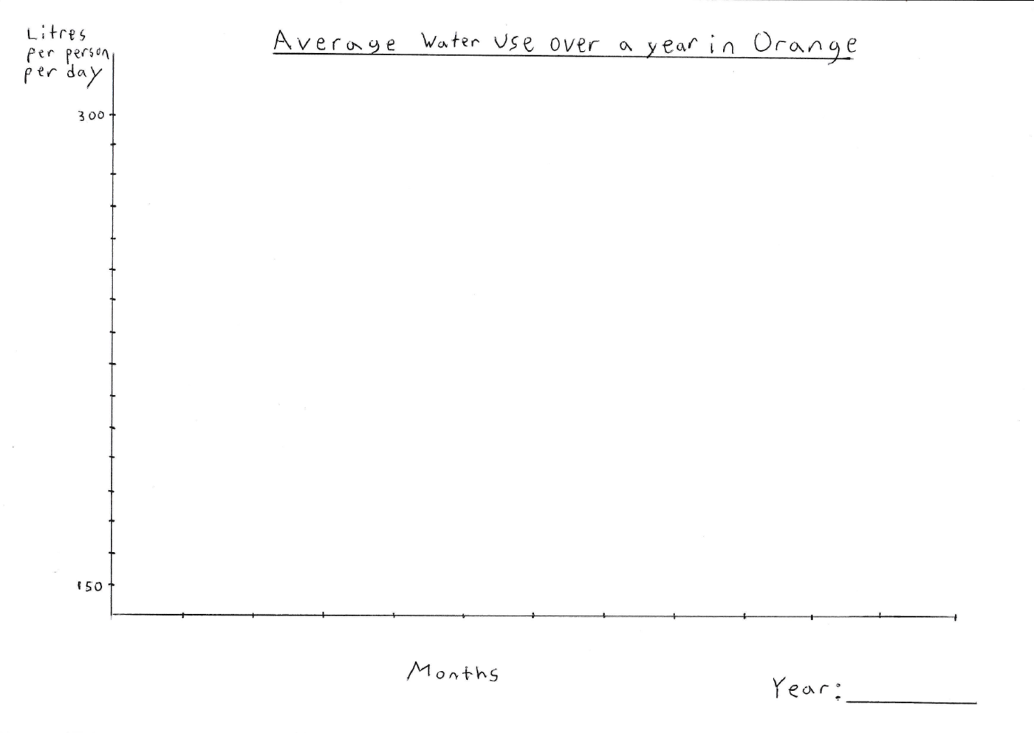

HARVESTING STORMWATER IN ORANGE
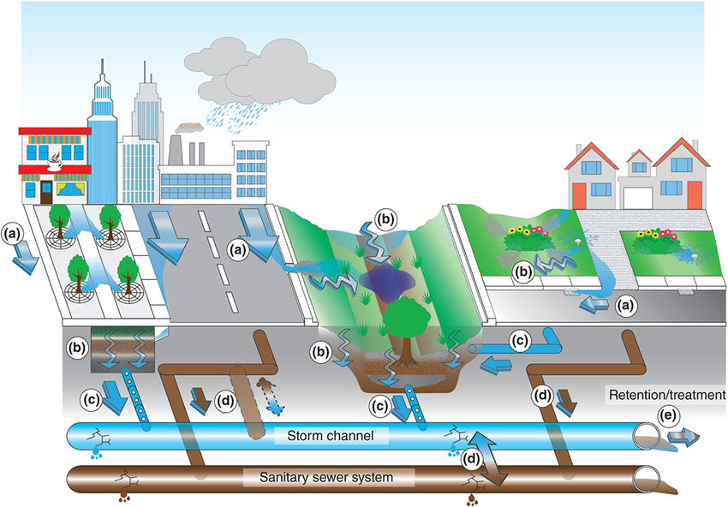

EXPLANATION
(A) Precipitation falling on paved surfaces is collected and directed toward underground storm channels through street gutters
(B) Precipitation can also fall on green surfaces inside a city and infiltrate into the ground
(C) Infiltrated water can be collected with underground drains and be added to the storm channels
(D) Contamination of sewer water and storm water can happen if the pipes are old, so storm water must be treated to be made safe
(E) Storm water channels are sent to water treatment systems for drinking quality or to a reservoir for storage and future use

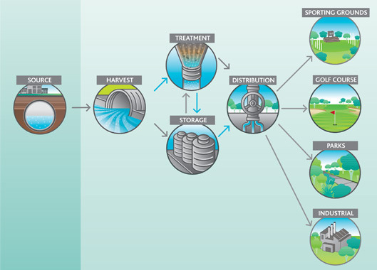

INSTRUCTIONS
Create your own diagram that illustrates how storm water can be collected by Orange to be used or stored for future use. View the provided diagrams here as a guide.
Your diagram must:
• be made with care with a neat and tidy appearance
• be coloured with labels explaining the features of your diagram
• show an example of storm water being collected, being transported, being used, and being stored
• show an example of precipitation, infiltration, and runoff
• have a border and a title

Written Response on Water Consumption
Water in the City of Orange
• Write a reflection on water usage in Orange [you can type it if you wish]
• In your written response you must mention the following topics
1) Provide the seasons in which water is most and least used [use the data you collected]
2) Explain why water usage is different as seasons change [use the graph you created]
3) Describe how Orange collects, stores, and uses storm water [use the diagram you created]
4) Determine how storm water storage can be important during times of drought.

More space next page

