Full name:
Teacher:
Due date:

YEAR 9 5.1 MATHEMATICS
Assignment – Term 3
2022

Outcomes Assessed
Working Mathematically: Students
- Uses appropriate terminology, diagrams and symbols in mathematical contexts MA5.1-1WM
- Selects and uses appropriate strategies to solve problems MA5.1-2WM
- Provides reasoning to support conclusions that are appropriate to the context MA5.1-3WM

Content Assessed
Refer to the attached assignment booklet and instructions. Each student is to complete tasks of their choosing.

Weighting | 25% | Due:  This assignment is due to your classroom teacher 2 weeks from the date received (due in Week 7).

Penalties as per assessment booklet – Failure to submit the assignment within the negotiated time frame may result in an N-award in Mathematics.

Gardner’s Multiple Intelligences and Revised Blooms Taxonomy
This assignment has been designed to give all students an opportunity to best demonstrate their ability in Mathematics. Students can choose from tasks aligned to the different categories of Gardner’s Multiple intelligences. The tasks are also aligned to the Revised Bloom's Taxonomy - a multi-tiered model of classifying thinking according to six cognitive levels of complexity.
Thus, students can choose tasks according to their preferred modes of learning or try different styles of learning. Students are also able to revise and explore key concepts of this unit by completing lower-order tasks and then challenge themselves to develop their understanding and skills by completing higher-order tasks.

Instructions
Each box in the Task Grid (on the next page) is a task.

- You do not have to answer all the questions!
- You must complete a total of 25 marks worth of tasks.
- Most tasks will require you to write your answers on separate A4 paper that you will need to provide. Please clearly write your full name and the task number. Answer in sequential order.
- Please highlight on the Task Grid which tasks you are completing.

Marking

Marks are awarded based on the difficulty and amount of work required to complete each task. Marking guidelines are provided under each task description.

Task Grid
Multiple  Intelligences | Bloom’s Taxonomy: Six Thinking Levels
 | Knowing | Understanding | Applying | Analysing | Creating | Evaluating
Verbal/Linguistic  I enjoy reading, writing & speaking | 1) Earning an Income  2 marks | 2) Tax Deductions  2 marks | 3) Discounts  4 marks | 4) May the Force Be With You  4 marks | 5) Rix Index  5 marks | 6) Mathematics and Space  6 marks
Logical/  Mathematical  I enjoy working with numbers & science | 7) Right-Angled Triangle  1 mark | 8) Algebraic Alphabet  2 marks | 9) Amusement Park  3 marks | 10) Graphing Simple Interest  4 marks | 11) Composition of Gold in Jewellery  6 marks | 12) Tax Return  4 marks
Visual/Spatial  I enjoy painting, drawing & visualising | 13) Outlier  2 marks | 14) Seashells for Brothers  2 marks | 15) Time sheets  4 marks | 16) Area of Victoria  3 marks | 17) Folding Paper  4 marks | 18) Area Ratios  3 marks
Bodily/Kinaesthetic  I enjoy doing hands-on activities, sports & dance | 19) Body Angles  2 marks | 20) Netball Lines  2 marks | 21) Composite Figures  2 marks | 22) Max Running  3 marks | 23) Area Grid Puzzle  4 marks | 24) Set of Triangles  6 marks
Technology  I enjoy using computers | 25) Spreadsheet  2 marks | 26) Total Pay  2 marks | 27) International Date Line  3 marks | 28) Kahoot!  3 marks | 29) PowerPoint  3 marks | 30) Hire a Car  6 marks

Task Details

Verbal/Linguistic

Earning an income (2 marks)
There are several different ways in which people are paid for providing their labour, knowledge,
skills and services. People who work for themselves charge a fee, but most people work for an
employer. Complete the table below by listing two occupations for each type of income.

Method of payment | Description | Examples of occupations
Salary | A fixed amount per year, usually paid weekly or fortnightly. | 1)  2)
Wages | An hourly rate for an agreed number of hours per week, usually paid weekly or fortnightly. | 3)  4)
Piecework | Being paid for the number of items (pieces) produced or completed. | 5)  6)
Commission | People who are paid a percentage of the value of their sales. | 7)  8)

Marking
1/2 mark | Per 2 correct occupations for each type of income.

Tax Deductions (2 marks)

- In your own words, define a “tax deduction”?

- Choose one profession and describe at least 2 taxable deductions for that job?

Marking
1 mark | a) For correct answer.
1/2 mark | b) For each taxable deduction.

Discounts (4 marks)

The following items are all discounted.
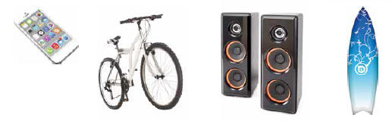

$\$380$ $\$450 \$260 \$600$
$25\% discount$ $20\% discount$ $33\frac{1}{3}\% discount$ $15\% discount$
- Which item has the largest dollar discount?
- Which two items have the same dollar discount?
- What is the difference between the largest and the smallest dollar discount?
- If the surfboard has a discount of $20\%$, would $\$470$ be enough to buy it?

Marking
1 mark | For each correct answer.

May the force be with you (4 marks)

- A Jedi Trainee must run past the army of battle droids in less than 2.5 seconds to rescue Chewbacca. How fast must the Jedi Trainee run (in m/s)?

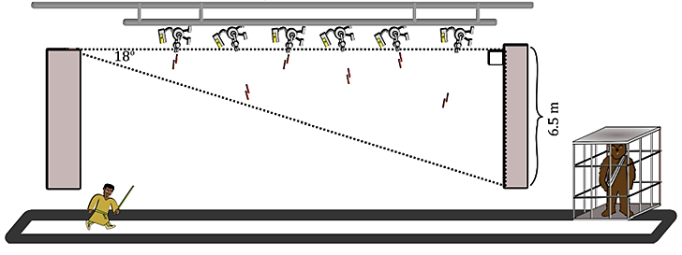

- The Empire is regrouping on the planet Tatooine. The angle of depression to the near side of the planet is 22º from the Millennium Falcon and the angle of depression to the far side is 15º. If the Millennium Falcon is 2,000,000 km above Tatooine, approximately how wide is the planet?

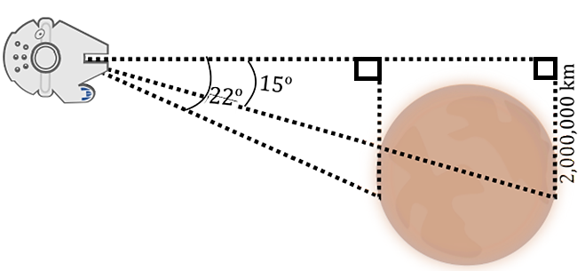

Marking
2 marks | a) Student calculated how fast the Jedi trainee must run with adequate working shown.
2 marks | b) Student calculated how wide the planet is with adequate working shown.

Rix Index (5 marks)
Since you first learned how to read, you have probably read many books. These books would have
ranged from picture books with simple words to books with short sentences. As you learned more
words, you read short stories and more challenging books. Have you ever picked up a book and put
it down straight away because you thought there were too many ‘difficult words’ in it?

The reading difficulty of a text can be described by a readability index. There are several different
methods used to calculate reading difficulty, and one of these methods is known as the Rix index.

The Rix index is obtained by dividing the number of long words by the number of sentences.

$$Rix Index= \frac{Number of Long Words}{Number of Sentences}$$

To determine the readability index, follow these guidelines:
- A long word is a word that contains seven or more letters.
- A sentence is a group of words that ends with a full stop, question mark, exclamation mark,
colon or semi-colon.
- Headings and numbers are not included, and hyphenated words count as one word.

Consider this passage from a Science textbook.
A fatal fall . . . or was it murder?
In 1991, some German hikers found a body preserved in ice near the Italy–Austria border. Scientists used radiometric dating and found that the body was about 5300 years old! They thought that the person, known now as the Iceman, had died of hypothermia (extreme cold). Ten years later, another group of scientists using high-tech X-rays found the remains of an arrowhead lodged near his left lung. Specialists have not yet confirmed whether the Iceman fell back onto his arrow, or if he was murdered. And without any witnesses to question, the truth may never be known!
- How many sentences and long words appear in this passage of text?

- Use your formula to calculate the Rix index for this passage. Round your answer to 2 decimal places.

Once you have calculated the Rix index, the table below can be used to work out the equivalent year level of the passage of text.
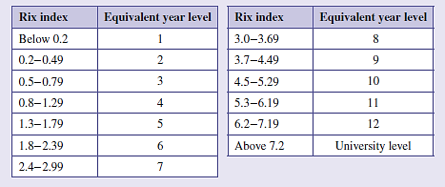

- What year level is the passage of text equivalent to?

- Choose a passage of text from a magazine or newspaper with at least 10 sentences and collect the required information for the formula. Calculate the Rix index and use the table above to determine the equivalent year level.
Note: Attach your passage of text with the assignment

Marking
1 mark | a) correct number of sentences and long words.
1 mark | b) correct Rix index with suitable working shown.
1 mark | c) correct year level.
2 marks | d) calculate the Rix index and correct year level with adequate working shown.

Mathematics and Space (6 marks)

Scientists work with many extremely large (and small) numbers, and it is not easy to use them in their basic numeral form. For example, the distance to the nearest star outside the solar system, Proxima Centauri, is 40 000 000 000 000 000 m, and the radius of a hydrogen atom is 0.000 000 000 025 m.

Such numbers can look a little clumsy. Counting the zeros can be hard on the eye, and it’s easy to
miss one. Furthermore, your calculator would not be able to fit all the digits on its screen!

Scientists use powers of 10 in a number system called scientific notation (or standard form). They
have also come up with prefixes that stand for certain powers of 10. There is a prefix for every third
power.

- Use either the internet and/or your notes from in class to complete the following table, which shows the scientific notation prefixes and abbreviations for a wide range of numbers. Note: SI is the abbreviation for International System of Units.
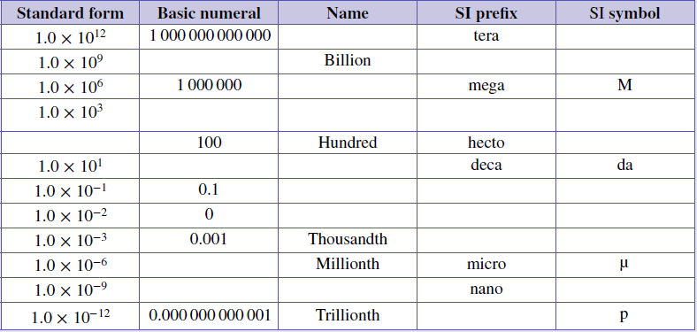

Proxima Centauri, near the Southern Cross, is the closest star to Earth and is 4.2 light-years away.
A light-year is the distance that light travels in 1 year. Light travels at 300 000 kilometres per second.

- Write 300 000 km/s in scientific notation.

- Find the distance travelled by light in 1 minute in scientific notation (km/min).

- Find the distance travelled by light in 1 hour in scientific notation (km/hr).

- Find the distance travelled by light in 1 day in scientific notation (km/day).

- Multiply your answer in part e) by 365.25 to find the length of a light-year in kilometres. Why do we multiply by 365.25? Write this distance in scientific notation.

- Calculate the distance from Earth to Proxima Centauri in kilometres.

Marking
2 marks | a) Table accurately completed.
1/2 mark | b) Correct solution.
1/2 mark | c) Correct solution with working.
1/2 mark | d) Correct solution with working.
1/2 mark | e) Correct solution with working.
1 mark | f) Correct solution with working and explanation.
1 mark | g) Correct solution with working.

Logical/Mathematical
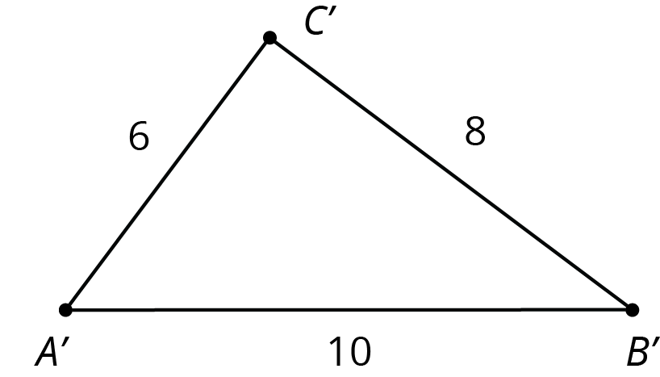

Right-Angled Triangle (1 mark)

Prove that the triangle displayed has a right angle, using $c^{2}= a^{2}+ b^{2}$ [Pythagoras’ Theorem]

Marking
1 mark | For the correct answer with adequate working shown.

Algebraic Alphabet (2 marks)

An expression contains 26 terms, one for each letter of the alphabet. It starts:

$a+4b+9c+16d+25e+$…
If the pattern were to continue:

- What would be the coefficient of f?
- Which pronumeral (letter) would have a coefficient of 400?
- What would be the 10th term in the pattern?
- What numbered term is 169m?

Marking
1/2 mark | For each correct answer.

Amusement Park (3 marks)

40% of the 7920 visitors to an Amusement Park were children. 25% of the children and $\frac{1}{3}$ of the adults were repeat visitors. What percentage of visitors were visiting the Amusement Park for the first time?

Marking
1 mark | Calculating the number of children and the number of adults who visited.
2 marks | Calculating the number of first-time visitors.
3 marks | Percentage of first-time visitors.

Graphing Simple Interest (4 marks)

Aiden invested $15000 at 3% per annum, simple interest for 4 years.

- Use the formula, $Interest=Principal ×rate ×number of years$, to complete the following table of values.
Number of years ($n$) | 1 | 2 | 3 | 4
Interest ($I$)

- Draw a graph with $n$ as the horizontal axis and $I$ as the vertical axis. Plot the points from the table of values on to the graph. Join the points to make a straight line.

- Using the graph, predict the total amount of interest after six years.

Marking
1 mark | a) Correct answers entered into a table.
2 marks | b) Graph correctly created.
1 mark | b) Graph correctly created with some minor errors.
1 mark | c) Correct answer predicted.

Composition of Gold in Jewellery (6 marks)

You may be aware that most gold jewellery is not made of pure gold. It is actually an alloy (a mixture of metals). The finest gold used in jewellery is 24 carat and is known as fine gold. Gold in this form is very soft and is easily scratched. Most metals will form an alloy with gold, with the most common in jewellery making being silver, copper and zinc. Other metals may be used to create coloured gold. A table of the composition of some of the common gold alloys used in jewellery pieces is shown below:

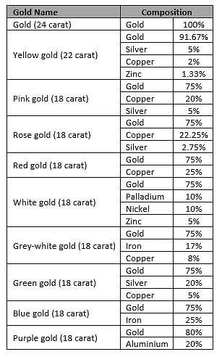
- Study the table and list the metals used to create the alloys of gold mentioned.

- A particular rose-gold bracelet weighs 36 grams. Calculate the masses of the various components in the bracelet.

- How much more gold would be in a yellow-gold bracelet of the same mass? What fraction is this of the mass of the bracelet?

- 24 -carat gold is classed as 100% gold. On this basis, an alloy of gold containing 75% gold has a carat value of 18 carat. Note this fact in the table above. The purple gold is 80% gold. What would its carat value be?

- Just as there are various qualities of gold used in jewellery making, the same is true of silver jewellery. Sterling silver, which is commonly used, is actually not pure silver. Find out about the composition of silver used in jewellery making. Write a short report on your findings on a separate sheet of paper (approximately 100 words).

Marking
1 mark | a) list all the alloys from the table.
1 mark | b) for correct answer with adequate working shown.
1 mark | c) for correct answer with adequate working shown.
1 mark | d) for correct answer with adequate working shown.
2 marks | e) report includes accurate findings with full sentences, correct punctuation, grammar and spelling.

Tax return (4 marks)

Milly has come to the end of her first financial year. She earned $2450 per fortnight for the whole year and she made $360 on investments. Throughout the year, Milly spent $400 on uniforms, donated $80 to charity, spent $150 on work related equipment and completed a training course which cost $75.

Taxable income | Tax on this income
0–$18 200 | Nil
$18 201– $37 000 | 19c for each $1 over $18 200
$37 001– $80 000 | $3 572 plus 32.5c for each $1 over $37 000
$80 001–$180 000 | $17 547 plus 37c for each $1 over $80 000
$180 001 and over | $54 547 plus 45c for each $1 over $180 000

- Calculate Milly’s Taxable Income.

- Use the tax table above to calculate the income tax Milly must pay.

- Milly also needs to pay the Medicare levy of 2% of her taxable income. How much is the Medicare levy?

- If Milly’s employer has sent in a total $14 500 of tax to the ATO, has Milly paid enough tax? How much of a refund or how much is still owing to/from the ATO?

Marking
1 mark | For each correct answer with adequate working shown.

Visual/Spatial

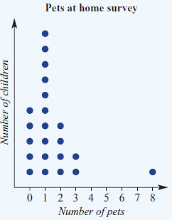
Outlier (2 marks)

Some children were asked the following question in a survey: “How many pets do you have at home?”
The responses are shown in the dot plot to the right.

a) What number is the outlier in the dot plot?

b) What number is the mode?

Marking
1 mark | For each correct answer

Seashells for Brothers (2 marks)

Grandma let Jon and Ron share her collection of seashells between them. Jon, being the older of the two, demanded a bigger share and took 160 seashells. Soon he realised he was being unfair.
So, he gave 32 of his seashells to Ron. This increased the number of seashells that Ron got by 25%.

How many total seashells were there in grandma’s collection? (Use the image below to help you)

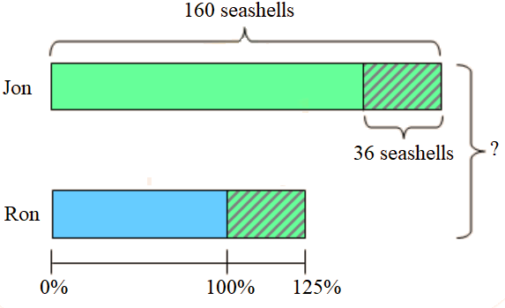

Marking
1 mark | Calculating Ron’s seashells
2 marks | Calculating total seashells

Time sheets (4 marks)
Fiona works in a department store. In the week before Christmas she worked overtime. Her time sheet is shown below. Fill in the details on her pay slip.

 | Start | Finish | Normal Hours | Overtime (x1.5)
M | 9.00 | 15.00 | 6
T | 9.00 | 17.00 | 8
W | 9.00 | 17.00 | 8
T | 9.00 | 19.00 | 8 | 2
F | 9.00 | 15.00 | 8 | 2
S
Pay slip for:  Fiona BLACK | Week ending  December 21
Total of normal hours
Normal rate | $17.95
Total of overtime hours
Overtime rate
Total wage

a) Total of normal hours

b) Total of overtime hours

c) Overtime rate

d) Total wage

Marking
1 mark | For each correct answer

Area of Victoria (3 marks)

The area of Victoria can be approximated using a right-angled triangle with the measurements shown below.
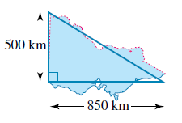

- Estimate the area of Victoria by calculating the area of the triangle.

- Use the internet to compare your estimate with the actual area of Victoria.

- Explain why the answer you obtained in part a) can be regarded only as an estimate.

Marking
1 mark | For each correct answer

Folding Paper (4 marks)
A square piece of paper, ABCD, of side length 30 cm is folded to form a right-angled triangle ABC. The paper is folded a second time to form a right-angled triangle ABE as shown in the diagram below. Glue your completed shape onto a separate sheet of paper or take a picture of your finished product.
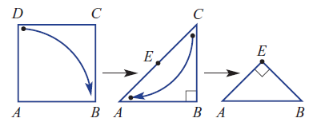

- Find the length of AC correct to two decimal places.

- Find the perimeter of each of the following, correct to one decimal place where necessary:
  - square ABCD
  - triangle ABC

- Use Pythagoras’ theorem and your answer for part a to confirm that AE = BE in triangle ABE.

- Investigate how changing the initial side length changes the answers to the above.

Marking
1/2 mark | Length of AC is calculated with all working shown.
1 mark | Perimeter of square ABCD and triangle ABC is calculated with all working shown
1/2 mark | Prove AE=BE in triangle ABE with all working shown
2 marks | Student sufficiently investigate and makes an accurate judgement on how changing the side length changes the answer and support this with mathematical calculations.

Area Ratio (3 marks)

Consider these three similar triangles (not drawn to scale).
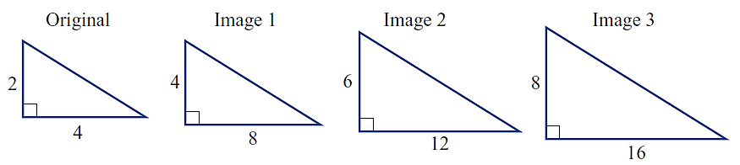

- Complete this table, comparing each image to the original.

Triangle | Original | Image 1 | Image 2 | Image 3
Length Scale Factor | 1 | 2
Area
Area Scale Factor | 1

- What do you notice about the area scale factor compared to the length scale factor? And what would be the area scale factor if the length scale factor is n? [Support your answer with mathematical calculations]

Marking
2 marks | Part a) Student completed the table
1 mark | Part b) answered correctly with adequate working shown.

Bodily/Kinaesthetic (Questions 19 to 24)

Body Angles (2 marks)

Using your body, demonstrate in one photo the following angles: right-angle, acute, reflex and supplementary angles. On your photo, clearly label the four angles. Attach the photo with your assignment.

Marking
1/2 mark | For each correct angle labelled.

Netball Lines (2 marks)

Using your knowledge of circles, in particular circumference, calculate the length of paint used to mark all lines. Show all marking for full marks.
30.5 m
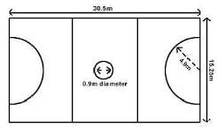

4.9m
15.25m

0.9m diameter

Marking
2 marks | Correct answer with adequate working
1 mark | Adequate working shown with one or more mistakes.

Composite Figures (2 marks)

Copy each of the following figures and divide them into the plane shapes specified. Attach the plane shapes with your assignment.

- 4 triangles b) 1 parallelogram and 1 triangle
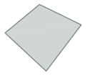

c) 1 kite and 4 triangles d) 1 quadrilateral and 2 triangles

Marking
1/2 mark | For each correct answer

Max Running (3 marks)
Conduct the following experiment at a running track/oval.

- Measure the amount of time it takes for a person to run 400m. Allow a 5-minute break, then measure the amount of time to run 100m. Record this data in a table.

- Calculate the speed of both scores in metres per second (m/s).

- Convert this speed into kilometres per hour (km/h)

Marking
1 mark | a) Data accurately entered into a table.
1 mark | b) For correct answer with adequate working shown.
1 mark | c) for correct answer with adequate working shown.

Area Grid Puzzle (4 marks)
Attached at the back of this booklet (APPENDIX A) is a series of shapes. You are to cut out each shape. Using all 12 pieces in any arrangement, fit these shapes in to the rectangles pictured below. Take a photo of each rectangle completed and attach it to the assignment.

Here is an example of a completed one (Do not use this solution as your own – there are many!)
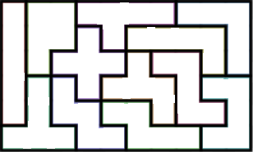

Marking
1 mark for each rectangle | Photo correctly depicts the rectangle being successfully covered by the cut-out shapes.

Set of Triangles (6 marks)

For each of the sets of shapes below, follow these instructions to investigate the pattern.

- Using pencils or similar objects, construct the above figures. Draw the next two figures in the series.

- Construct a table to show the relationship between the number of triangles in the figure and the number of matchsticks used to construct it.

Number of triangles (n) | 1 | 2
Number of matches (m) | 3

- Devise a rule in words that describes the pattern relating the number of shapes in the figure and the number of matchsticks used to construct it.

- Use your rule to work out the number of matchsticks required for make a figure made up of 17 triangles. Check your answers by drawing the figures and counting the number of matchsticks required.

- Draw the first 3 figures that could be represented by the rule m = 5n + 3, where m is the number of matchsticks and n is the number of shapes.

Marking
1 mark | a) Drawn correct figures
1 mark | b) Table accurately completed
1 mark | c) Correct rule identified and described
1 mark | d) Correct solution identified
2 marks | e) Correct matchstick patterns created

Technology

Use the data below for questions 25 and 26.
The data shows the pay rates and the number of hours worked for the employees of a factory.

Employee | Rate  ($/h) | Normal time  (h) | Overtime (h)  time-and-a-half | Overtime (h)  double-time | Total  Pay
Brody | 24.72 | 36 | 8 | 4
Chloe | 18.94 | 36 | 6 | 1
Alan | 23.65 | 28 | 5 | 2
Gillian | 26.36 | 35 | 4 | 3
Natasha | 33.56 | 30
Yami | 19.43 | 40 | 1 | 1

Spreadsheet (2 marks)

Enter the above data into an Excel spreadsheet. Submit a screenshot

Marking
2 marks | Data accurately entered into a spreadsheet
1 mark | Data entered into spreadsheet with some minor errors

Total pay (2 marks)
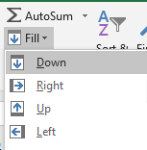
In cell F2 type the formula $=(C2+D2*1.5+E2*2)*B2$

- To find the total pay for the other employees:

- Highlight cells F2 to F7.

- Go to Home.

- Select Fill Down. See the screenshot to the right.

- Add at least 5 more employees. Enter their pay rates and the numbers of hours worked. Calculate their total pays.

Marking
1 mark | a) Column added with all total pays calculated
1 mark | b) 5 more employees added with their pay rates and number of hours worked

International Date Line (3 marks)
Use the Internet to research the purpose of the International Date Line (IDL). Write a report that answers the following questions. Attach the report with your assignment.

- What is the International Date Line?

- Why do we have it?

- When was it created/agreed upon?

- Why is it not a straight line?

- How is it possible to gain or lose a day while travelling throughout the world?

Marking
3 marks | Report is detailed and answers all of the questions above.
2 marks | Report is missing 1 – 2 answers for the questions listed.
1 mark | Report lacks depth and does not address 3 or more of the questions in detail.

Kahoot (3 marks)

Create a Kahoot with at least 10 questions using real life applications of financial mathematics. Your questions must include a question on each of the following:
- wages
- salaries
- overtime
- piecework
- commission
- tax
- simple interest

Take screenshots of each question and submit these with your assignment.

Marking
3 marks | The Kahoot contains at least 10 questions including the concepts listed
2 marks | The Kahoot contains 10 questions but is missing one or two of the concepts listed
1 mark | The Kahoot is missing more than 2 of the financial concepts listed

PowerPoint (3 marks)

Create a PowerPoint that could be used to teach a person one of the mathematical concepts that you have studied this year. This PowerPoint must be a minimum of 5 slides, include any definitions, explanations or formulas. It should also include numerous different examples.

Submit a copy of this PowerPoint with your assignment.

Marking
1 mark | The PowerPoint contains at a formula and/or definition but with no examples.
2 marks | The PowerPoint teaches the concept, with minimal examples or examples that lack variety.
3 marks | The PowerPoint is comprehensive with definitions, formulas and at least three varying examples.

Hire a car (6 marks)

A group of tourists have just arrived at Sydney airport and are investigating the best hire car deals.
They decide to study the different options offered by Orange Car Rentals.

Option 1 | $60 per day unlimited kilometres
Option 2 | $30 per day and 25 cents/km
Option 3 | $40 per day and 35 cents for every kilometre over 100 each day

The group know that on their first day they will be visiting the local attractions close to Sydney, so they will not be travelling many kilometres.

- How much would each option cost if the total kilometres travelled in a day was 90 km?

(Task 30 continues over the page)
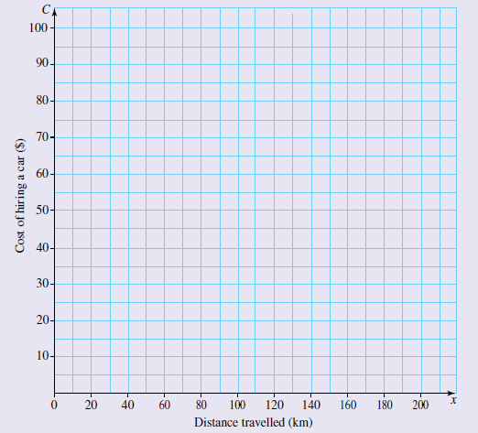
- Use Microsoft Excel to plot the graphs of the three options on the set of axes provided to show the cost of hiring a car for a day to travel 200 km. Submit a screen shot.

- Examine the graphs of the three options carefully. Write a brief statement in Microsoft Word (approximately 150 words) to explain the costs associated with each option over 200 km. Submit a typed word document.

Marking
1 mark | a) Correct solution and working
2 marks | b) Graph correctly created
1 mark | b) Graph correctly created with some minor errors
2 marks | c) Statement includes accurate findings with full sentences, correct punctuation, grammar and spelling

Overall marking comments
APPENDIX A (Task 16)

