UNIFORM
The wearing of school uniform is a condition of enrolment at Orange High School. We feel that appropriate school uniform is a means of fostering school pride. If you are out of uniform for any reason, you must have a note from home to explain why. This note should be presented to the Deputy Principal before school. The school can assist any student who has difficulty obtaining uniform. Students can wear uniform from either column.
 | Junior Uniform - Shorts/ Pants Option | Junior Uniform - Skirt/Skort/Tailored pants option
Summer | Regulation grey shorts | Knee length black & white check skirt OR black & white check skort
Winter | Long grey trousers | Black, tailored slacks
Shirt | White with collar & school crest | White with collar & school crest
Junior Jumper | Black with gold bands | Black with gold bands
Polar Fleece | Black with school crest | Black with school crest
Coat | Black OHS anorak with school crest | Black OHS anorak with school crest
Junior Tie | Black with gold stripes | Black with gold stripes
Socks | White or grey ankle | White ankle
Shoes | Black leather lace up | Black leather lace up
Hat | Black bucket style with school crest | Black bucket style with school crest

 | Senior Uniform - Shorts and Pants Option | Senior Uniform - Skirts and Pants Option
Summer | Regulation grey shorts | Knee length black pleated skirt or black shorts or pants
Winter | Tailored long black trousers | Long ankle length pleated skirt or black pants
Shirt | White with collar | White ‘Peter Pan’ collar
Senior Jumper | Black with gold school crest | Black with gold school crest
Polar Fleece | Black with school crest | Black with school crest
Coat | Black OHS anorak with school crest | Black OHS anorak with school crest
Senior Blazer (Optional) | Black with gold school crest on pocket | Black with gold school crest on pocket
Senior Tie | Black with school crest | Black with school crest
Socks | Black socks (with black trousers) | White ankle socks or black stockings
Shoes | Black leather lace up | Black leather lace up
Hat | Black bucket style with school crest | Black bucket style with school crest

 | Sports Uniform
Tracksuit | Black, gold and white school jacket and black tracksuit pants
Shirt | Black and gold polo with collar and OHS embroidered crest
Shorts | Black, drawstring waist
Pants | Black tracksuit pants
Shoes | Joggers
Jumper | Regular school jumper

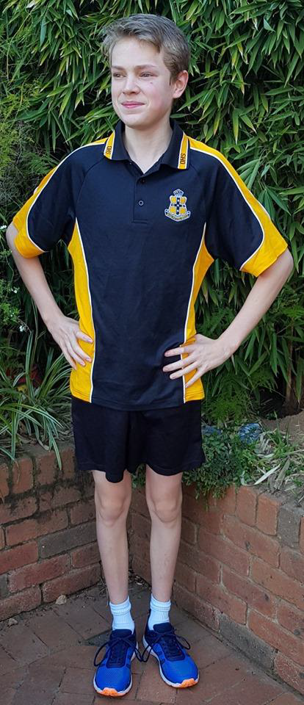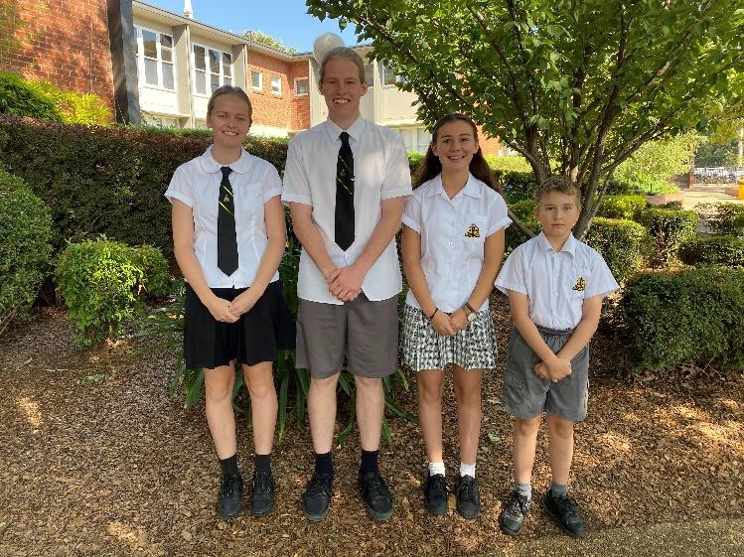

Winter Uniform Options Full Summer Options

Sports Uniform

