ORANGE HIGH SCHOOL

ASSESSMENT TASK
Subject | Earth and Environmental Science
Topic | Earth’s Resources
Class Teacher | Ms J Mansur
Head Teacher | MS J Huggett
Year | 11
Date Given | Tuesday Week 11 Term 1 2023
Date Due | Friday (Week 1, Term 2)
Weighting | 30%

Assessment Outline
As part of the Preliminary Earth & Environmental Science course, students will be required to investigate how non-renewable geological resources are extracted.

The Task:
- Undertake an investigation to model how geological resources are recovered and analyse the profitability of operating the mine and the restoration of damaged lands after mining operations cease.

- Complete a depth study to describe the locations and extraction methods of mining copper with a focus on Cadia Mine.

Investigation: Cookie Mining
- Extraction of the ‘ore’
- Calculating equipment used, total cost of mining and total profit
- Analyse why the reclamation of the mine should be considered when calculating the economic profitability of the mine.

Depth study: Copper as an ore of economic importance
- a description of how copper is extracted including a labeled diagram
- a flow chart detailing the stages in processing the copper ore to copper metal
- identify locations where copper is extracted in Australia (including a labeled diagram)
- provide detail on the operations of Cadia mine
- an assessment of the environmental effects of the mining method

Your report will include the investigation and the depth study.

Your report should use multiple sources of information and all should be correctly cited using the APA style (got to: https://www.citethisforme.com).
The task is worth 30% of your course marks.

Non-completion of Task:
If you know you are going to be away on the day that the task is due, you must make alternative arrangements with your teacher beforehand. If you are suddenly away on the day that the task is due, you must contact your teacher or Head Teacher on your return to school. Documentation will be required in both cases.
Plagiarism:
Plagiarism, the using of the work of others without acknowledgement will incur serious penalties and may result in a zero award. Any cheating will also incur penalties.

Failure to follow the above procedures may result in a zero award.
The policies and procedures that are outlined in the OHS Preliminary assessment booklet will be followed regarding the non-completion of assessment tasks.

Outcomes Assessed
This task will evaluate a student’s ability in the following course outcomes.

- EES11-8 - describes the key features of the Earth’s systems, including the geosphere, atmosphere, hydrosphere an hydrosphere and biosphere and how they are interrelated
- EES11-1 Questioning and predicting
- develop and evaluate inquiry questions and hypotheses to identify a concept that can be investigated scientifically, involving primary and secondary data
- EES11-2 Planning investigations
- assess risks, consider ethical issues and select appropriate materials and technologies when designing and planning an investigation
- EES 11-4 Processing data and information
- apply quantitative processes where appropriate
- EES 11-6 Problem solving
- solves scientific problems using primary and secondary data, critical thinking skills and scientific processes

 | Extensive | Thorough | Sound | Basic | Elementary
 | A | B | C | D | E
Calculations  WS 11.4 | All components are completed  Calculations are correct |  | Some components are completed  Some calculations are correct |  | Minimal components are completed  Some calculations are attempted
 | 3 |  | 2 |  | 1
Diagram  WS 11.4 | Clear diagrams of cookie which are accurately drawn and labelled  3 completed diagrams |  | Some diagrams of cookie are accurately drawn  2 or less diagrams included |  | Simple cookie diagrams included
 | 3 |  | 2 |  | 1
Conducting the investigation  WS 11.2 | Employs safe work practices and conducted experiment in an effective manner |  | Issues with safety AND/OR did not use time effectively |  | Issues with safety AND did not use time effectively
 | 3 |  | 2 |  | 1
Depth Study Description  WS 11.6 | Extensive evaluation of mining extraction, detailed diagram included | Thorough evaluation of mining extraction, includes a diagram | Evaluation of mining extraction | Description of mining extraction included | Basic description of mining extraction
 | 5 | 4 | 3 | 2 | 1
Depth Study  Flow Chart  WS 11.6 | Exceptional flow chart and explanation of all stages in the processing of copper | Flow chart detailing all stages in the processing of copper, summary of process included | Flow chart including all stages in the processing of copper | Flow chart included | Flow chart included but missing some steps
 | 5 | 4 | 3 | 2 | 1
Depth Study  Locations identified  WS 11.6 | Clearly identifies all locations in Australia where copper is extracted including a detailed diagram | All locations identified in Australia with diagram | Some locations identified in Australia with basic diagram | Limited locations identified in Australia with basic diagram | Limited locations identified in Australia
 | 5 | 4 | 3 | 2 | 1
Depth Study  Cadia Mine Operation  WS 11.8 | Detailed explanation of the Cadia Mine operations | An explanation of the Cadia Mine operations | Information of the Cadia Mine operations | Cadia Mine operations are included but no detail provided | Brief mention of the Cadia Mine operations
 | 5 | 4 | 3 | 2 | 1
Depth Study Environmental Effects  WS 11.8 | Detailed assessment of the impacts of mining on the environment | Environmental effects of mining methods assessed thouroughly | Environmental effects of mining method description is satisfactory | Environmental effects of mining methods included | Little information on the environmental effects of mining included
 | 5 | 4 | 3 | 2 | 1
Reference list  WS 11.1 | Extensive (more than 10) reference list is included and is correctly formatted using the APA style |  | Reference list is included but the list is not correctly formatted |  | An attempt at a reference list has been made
 | 3 |  | 2 |  | 1
Conclusion  WS 11.6 | Extensive analysis of considering the economic profitability of the mine | Through analysis of considering the economic profitability of the mine | Explanation considering the economic profitability of the mine | Description in considering the economic profitability of the mine | Basic description of considering the economic profitability of the mine
 | 5 | 4 | 3 | 2 | 1

WS 11.4 | /6 | Feedback:
WS 11.2 | /3
WS 11.6 | /20
EES 11.8 | /10
WS 11.1 | /3
Total | /42

Cookie Mining
Materials:
Chocolate chip cookie ($3); Jumbo chip cookie ($5)
Grid paper
Toothpick
Paper clips

Directions:
Special Instructions:

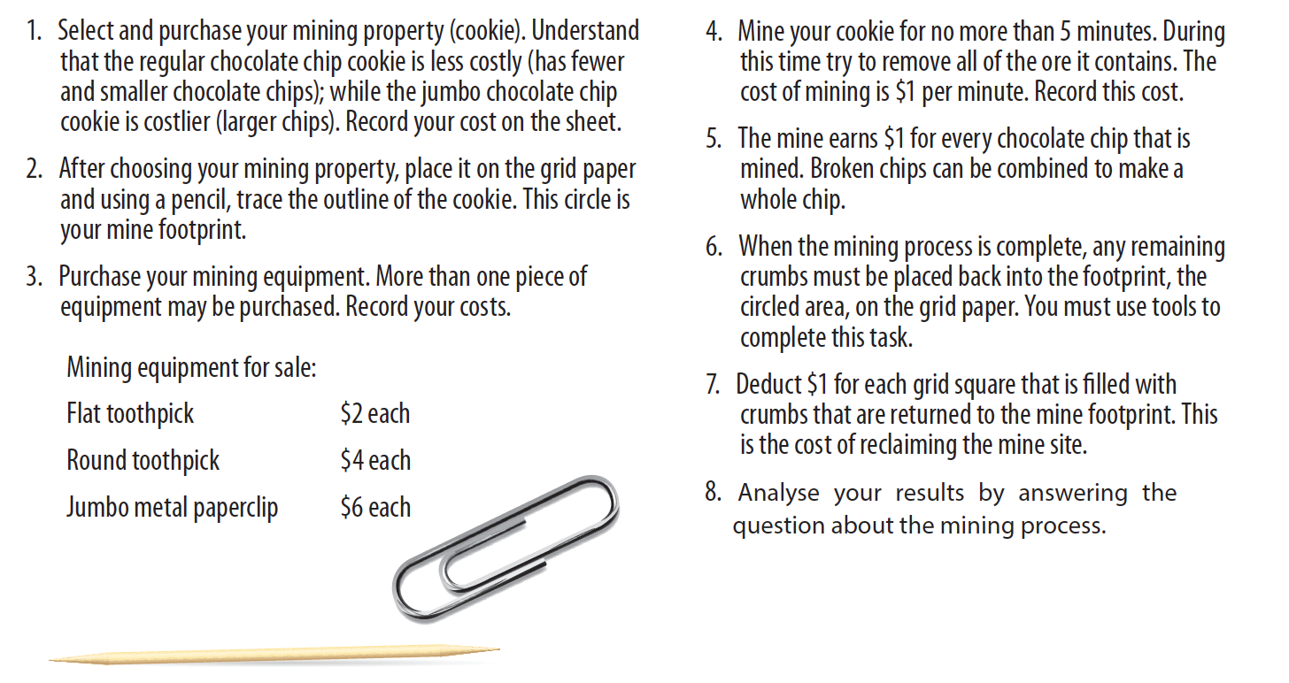

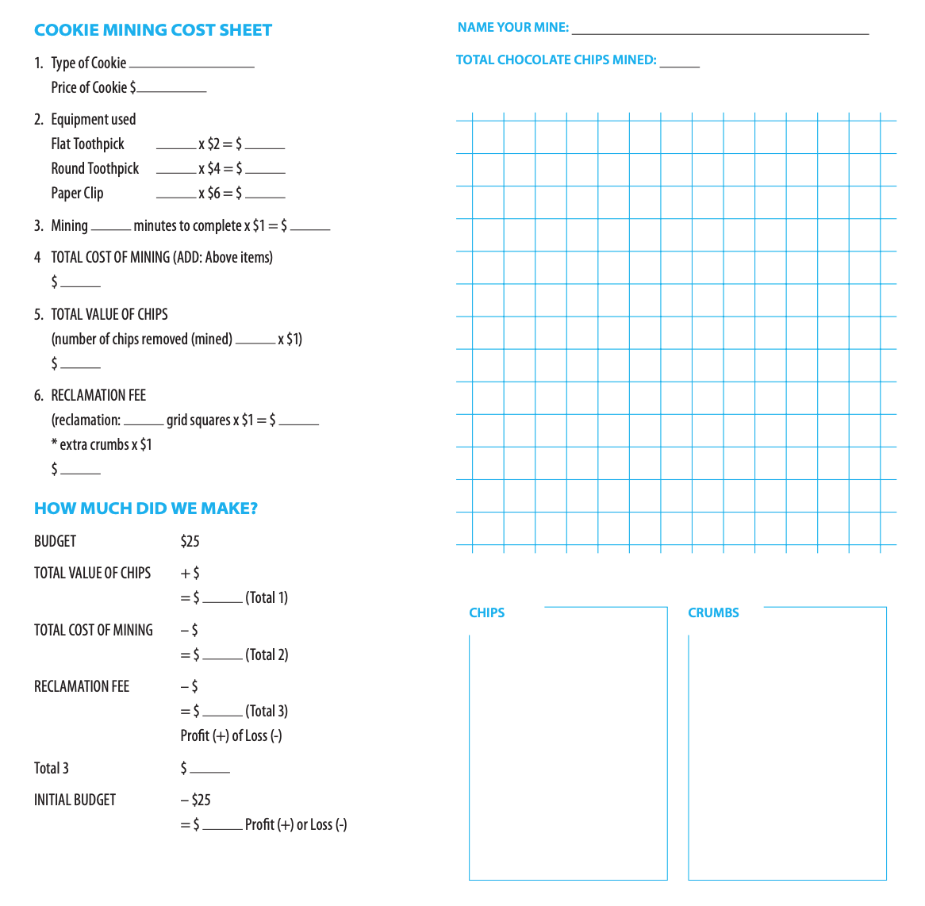
Conclusion:

Analyse why the reclamation of the mine should be considered when calculating the economic profitability of the mine? (5 marks)

________________________________________________________________________________________________________________________________________________________________________________________________________________________________________________________________________________________________________________________________________________________________________________________________________________________________________________________________________________________________________________________________________________________________________________________________________________________________________________________________________________

