Full name:
Teacher:
Due date:

YEAR 7 MATHEMATICS
Assignment
2022
Outcomes Assessed
- MA4-1WM communicates and connects mathematical ideas using appropriate terminology, diagrams and symbols
- MA4-2WM applies appropriate mathematical techniques to solve problems
- MA4-3WM recognises and explains mathematical relationships using reasoning

Content Assessed
Refer to the attached assignment booklet and instructions. Each student is to complete tasks of their choosing.
Weighting | 25% | Due:  This assignment is due to your classroom teacher 2 weeks from the date received (due in Week 7).

Gardner’s Multiple Intelligences and Revised Blooms Taxonomy
This assignment has been designed to give all students an opportunity to best demonstrate their ability in Mathematics. Students can choose from tasks aligned to the different categories of Gardner’s Multiple intelligences. The tasks are also aligned to the Revised Bloom's Taxonomy - a multi-tiered model of classifying thinking according to six cognitive levels of complexity.
Thus, students can choose tasks according to their preferred modes of learning, or try different styles of learning. Students are also able to revise and explore key concepts of this unit by completing lower-order tasks and then challenge themselves to develop their understanding and skills by completing higher-order tasks.

Instructions
You do not have to answer all the questions!
Each box in the Task Grid (on the next page) is a task.

- 7MA1 & 7MA2 must include at least two tasks from the creating column and at least two tasks from the evaluating columns as part of their 30 marks.
- 7MA3, 7MA4, 7MA5, 7MA7 must include at least one task from the creating column and at least one task from the evaluating columns as part of their 25 marks.
- 7MA6 must complete a total of 20 marks.
- Most tasks will require you to write your answers on separate A4 paper that you will need to provide. Please clearly write your full name and the task number. Answer in sequential order. Use a separate sheet of A4 paper for each question.
- Please highlight on the Task Grid which tasks you are completing.

Marking

Marks are awarded based on the difficulty and amount of work required to complete each task. Marking guidelines are provided under each task description.

Task Grid
Multiple  Intelligences | Bloom’s Taxonomy: Six Thinking Levels
 | Knowing | Understanding | Applying | Analysing | Creating | Evaluating
Verbal/Linguistic  I enjoy reading, writing & speaking | 1) Synonyms  (2 marks) | 2) Supporters  (2 marks) | 3) What’s on the back?  (2 marks) | 4) Consecutive Numbers  (2 marks) | 5) The Number 2  (3 marks) | 6) Digit Detector  (2 marks)
Logical/  Mathematical  I enjoy working with numbers & science | 7) Oldest Record  (1 mark) | 8) Fastest Time  (2 marks) | 9) Dizzy Digits  (3 marks) | 10) Distance  (2 marks) | 11) The Largest Number  (2 marks) | 12) So Many Sums  (4 marks)
Visual/Spatial  I enjoy painting, drawing & visualising | 13) The Australian Medal Tally  (3 marks) | 14) Balloon Bursting  (2 marks) | 15) Where should the numbers go?  (2 marks) | 16) Multiplication Table  (3 marks) | 17) Drawing Letters  (3 marks) | 18) Broken Machine  (3 marks)
Bodily/Kinaesthetic  I enjoy doing hands-on activities, sports & dance | 19) Counting Cars  (2 marks) | 20) Not 3 in a Line  (3 marks) | 21) Heights  (3 marks) | 22) Flextangles  (2 marks) | 23) Kahoot  (3 marks) | 24) Paper Planes  (3 marks)
Technology  I enjoy using computers | 25) Spreadsheet  (2 marks) | 26) Difference  (3 marks) | 27) Average Temperatures  (2 marks) | 28) New York  (3 marks) | 29) PowerPoint  (3 marks) | 30) Comparing Number Systems  (5 marks)

Task Details

Verbal/Linguistic

Synonyms (2 marks)
List 3 synonyms for each of the following words: addition, subtraction, multiplication and division

Marking
1/2 mark | For each correct group of 3 synonyms for each term

Supporters (2 marks)
A crowd of 29 641 attended the 2022 NRL match between the Bulldogs and the Dragons. If 17 492 people supported the Bulldogs and the rest supported the Dragons, how many supporters did the Dragons have? Show all working out.

Marking
2 marks | Correct solution with all working shown
1 mark | Correct solution with no working

What’s on the back? (2 marks)

Four cards each have a number written on one side and a property written on the other.

The four numbers are 2, 5, 7 and 12.

The four properties are:
- Divisible by 7
- Odd
- Prime
- Greater than 10

On each card, the number written does not have the property that is written on the other side. What are the four number-property pairs?

Marking
1/2 mark | For each correct pairing

Consecutive Numbers (2 marks)

The difference of the squares of two consecutive odd numbers is 32. What are the two odd numbers? Show all working.

Marking
2 marks | Correct solution and working
1 mark | Working out demonstrates an understanding of squares, odd numbers and consecutive numbers.

The Number 2 (3 marks)

Write a 300 word story about the adventures of the number 2. Your story must include the concepts of addition, subtraction, multiplication and division.
Your story should be imaginative and must be typed or neatly printed.

Marking
3 marks | Detailed and original story that meets the word limit and includes the concepts of addition, subtraction, multiplication and division
2 marks | Some concepts are included and meets the word limit.
1 mark | Story does not meet the required word limit and include some concepts.

Digit detector (2 marks)

What number am I?

            - I am a 3 digit number
            - I am an odd number
            - I am divisible by 5
            - Each of my digits is different
            - My digits add up to 8
            - The tens digit is smaller than the hundred digit
            - I am less than 300
            - I have only one even digit

Marking
2 mark | Correct number that meets all requirements
1 mark | Number contains 1 or 2 minor errors

Logical/Mathematical

The table below shows the Commonwealth Records for the Men’s athletics events. Use the table to answer Questions 7 and 8

Event | Record | Name | Nation | Year
100 m | 9.88 | Ato Boldon | Trinidad and Tobago | 1998
200 m | 19.97 | Frankie Fredericks | Namibia | 1994
400 m | 44.24 | Kirani James | Grenada | 2014
800 m | 1:43.22 | Steve Cram | England | 1986
1500 m | 3:32.16 | Filbert Bayi | Tanzania | 1974
5000 m | 12:56.41 | Joshua Cheptegei | Uganda | 2018
10000 m | 27:19.62 | Wilberforce Talel | Kenya | 2002
Marathon | 2:09:12 | Ian Thompson | England | 1974
110 m hurdles | 13.08 | Colin Jackson | Wales | 1990
 | 13.08 | Colin Jackson | Wales | 1994
400 m hurdles | 48.05 | Louis van Zyl | South Africa | 2006
3000 m steeplechase | 8:10.08 | Conseslus Kipruto | Kenya | 2018
High jump | 2.36 m | Clarence Saunders | Bermuda | 1990
Pole vault | 5.80 m | Steven Hooker | Australia | 2006
Long jump | 8.41 m (+0.6 m/s) | Luvo Manyonga | South Africa | 2018
Triple jump | 17.86 m | Jonathan Edwards | England | 2002
Shot put | 22.45 m | Tomas Walsh | New Zealand | 2018
Discus throw | 68.20 m | Fedrick Dacres | Jamaica | 2018
Hammer throw | 80.26 m | Nick Miller | England | 2018
Javelin throw | 88.75 m | Marius Corbett | South Africa | 1998
Decathlon | 8663 pts | Daley Thompson | England | 1986
20 km walk | 1:19:34 | Dane Bird-Smith | Australia | 2018
50 km walk | 3:42:53 | Nathan Deakes | Australia | 2006
4 × 100 m relay | 37.58 | Usain Bolt  Kemar Bailey-Cole  Nickel Ashmeade  Jason Livermore | Jamaica | 2014
4 × 400 m relay | 2:59.03 | Michael McDonald  Roxbert Martin  Gregory Haughton  Davian Clarke | Jamaica | 1998

Oldest Record (1 mark)

Which event/s have records that have stood for the longest length of time?

Marking
1 mark | Correctly identified events/records

Fastest Time (2 marks)

If the 400m record holder ran the 100m event, how long would you expect it to take him? How does this time compare with the record of 9.88 seconds?

Marking
1 mark | Correct calculation of time with working out
1 mark | Correct statement in comparing the timings

Dizzy Digits (3 marks)

Using +, -, x and ÷ complete each of the following:

- Use four 4’s to make 44
- Use five 5’s to make 55
- Use six 6’s to make 66

Marking
1 mark | For each correct answer

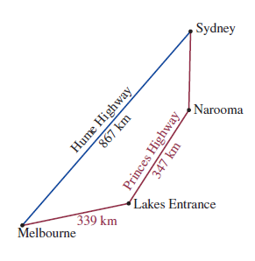
Distance (2 marks)

Lucy and Ty were driving from Melbourne to Sydney for a holiday. The distance via the Hume Highway is 867 kilometres, but they chose the more scenic Princes Highway route even though the distance is 1039 kilometres. They drove to Lakes Entrance the first day (339 kilometres), a further 347 kilometres to Narooma on the second day and arrived in Sydney on the third day.

- How much further is Melbourne to Sydney via the Princes Highway than via the Hume Highway? Show working out.

- How far did Lucy and Ty travel on the third day? Show all working out.

Marking
1 mark | Part a) Correct solution with working
1 mark | Part b) Correct solution with working

The Largest Number (2 marks)

Using the numbers 2, 4, 6 and 8 and +, x and =, what is the largest number that can be made? Show your working.

Marking
2 marks | Correct solution with working

So Many Sums (4 marks)

In this addition, each letter stands for a different digit, with S standing for 3
Find the value of each letter

What is the value of Y x O?

Marking
1/2 mark | For each correct value of the letter
1 mark | Correct value of Y x O

Visual/Spatial

The Australian Medal Tally (3 marks)

'Sports' is one of the variables shown on the graph. What is the other variable?

b) What are the top two silver medal winning sports?

c) In which sport were the most gold medals won?

d) In which sport were the least number of gold medals won?

e) Provide two reasons why the swimming team won the most medals.

Marking
2 marks | Correct responses for a) to d) (1/2 mark each)
1 mark | Correct reasons part e)

Balloon Bursting (2 marks)

If a number in one of the balloons is included in the answers to the three problems below then that balloon will fly away. Which balloon is left?

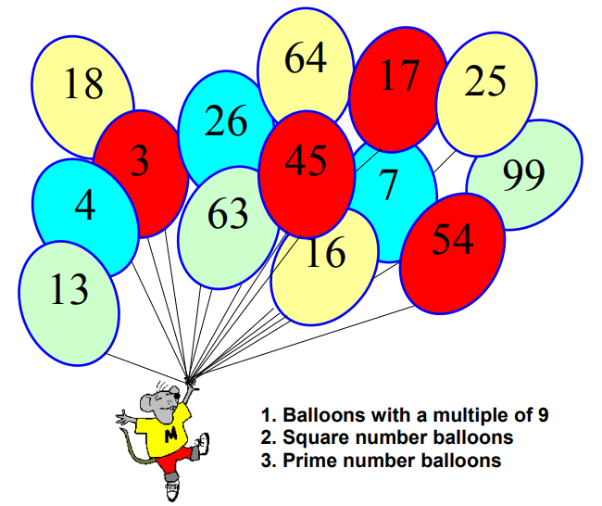

Marking
2 marks | Correct solution found

Where should the numbers go? (2 marks)
Arrange the numbers 1, 2, 3, 4, 5, 6, 7 and 8 inside these circles so that no two consecutive numbers are in connected circles

Remember: Consecutive means one after the other e.g. 2 and 3

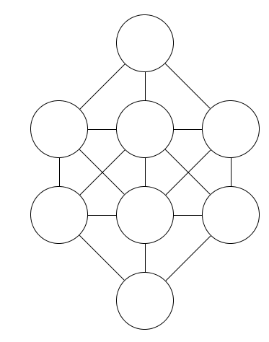

Marking
2 marks | Correct solution
1 mark | 1 mistake present in the solution

Multiplication Table (3 marks)
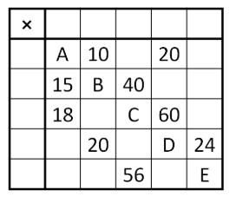

In the multiplication table on the right, the row and column headings are all missing, and only some of the products in the table are filled in.

All the numbers in the table are positive integers.

- Complete the table

- What is the value of A + B + C + D + E?

Marking
2 marks | Part a) Table accurately completed
1 mark | Part b) Correct solution

The following information is required for Questions 17 and 18

In Bob’s factory, there are 10 machines. Each machine performs only one specific job as displayed below.

• Machine 1 makes letters 1 cm high.
• Machine 2 enlarges the letters, so they are twice as high as machine one.
• Machine 3 enlarges the letters, so they are 3 times as high as machine one.
• Machine 4 enlarges the letters, so they are 4 times as high as machine one.
• Machine 5 enlarges the letters, so they are 5 times as high as machine one.
• Machine 6 enlarges the letters, so they are 6 times as high as machine one.
• Machine 7 enlarges the letters, so they are 7 times as high as machine one.
• Machine 8 enlarges the letters, so they are 8 times as high as machine one.
• Machine 9 enlarges the letters, so they are 9 times as high as machine one.
• Machine 10 enlarges the letters, so they are 10 times as high as machine one.

Drawing Letters (3 marks)

Select one letter from the alphabet, draw this letter as it would appear when printed from machine 1. This printout is then placed into machine 3, draw the printout. The printout from machine 3 is then placed into machine 5, draw the printout.

Marking
1 mark | 1 mark for each correct drawing

Broken Machine (3 marks)

Bob has a thriving business and relies heavily on all his machines working. This morning he arrived to process a large order of 6-cm-high letters only to find that machine 6 was not working. He gathered his staff together to discuss the problem.

‘No problem!’ said Ken. ‘As long as the other machines are working we can still get this order done’.

- Suggest a solution that Ken might have proposed.
- If Bob can do without machine 6, are there others he can also do without? Explain your answer.

Marking
1 mark | part a) Correct solution identified
2 marks | part b) Correct machines identified with explanations

Bodily/Kinaesthetic

Counting Cars (2 marks)
Stand on the pavement of a street and record the colours of 30 cars in the table below.

Car Colour | Tally | Frequency (Number)
White
Black
Red/Maroon
Grey/Silver
Blue
Green
Other

Marking
2 marks | Table completed with a total of 30 cars
1 mark | Table has not been fully completed or survey did not include 30 cars

Not three in a line! (3 marks)

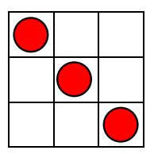
This 3 x 3 square has three counters in it in a row.

- How many counters can you place without getting three in a row? Draw their placement in the diagram below. The use of 5 cent coins may assist you.
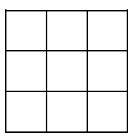

* Task 20 continues over the page

- How many counters can you place in a 4 x 4 square without getting 3 in a row? Draw their placement in the diagram below.

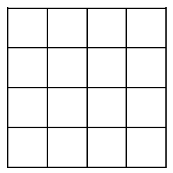

Marking
1 mark | Part a) Counters have been correctly placed and drawn on the diagram
2 marks | Part b) Counters have been correctly placed and drawn on the diagram

Heights (3 marks)

Measure the height, in centimetres, of five people. Record the heights in an appropriate format and submit with your assignment. Use these heights to answer the following questions.

- find the total

- find the difference between the shortest and tallest people.

Marking
1 mark | Heights recorded
1 mark | Part a) Correct total calculated
1 mark | Part b) Correct difference calculated

Flextangles (2 marks)

Create the “flextangle” paper shape on the last page of this assignment booklet. Submit this with your assignment

Marking
2 marks | Shape correctly created

Kahoot (3 marks)

Create a Kahoot with at least 10 mathematical based questions using real life applications of whole numbers, fractions, decimals and percentages. Take screenshots of each question and submit these with your assignment.

Marking
3 marks | The Kahoot contains at least 10 questions that are mathematics based.
2 marks | The Kahoot contains 10 questions but some are not mathematics based. Or The Kahoot contains only 7 to 9 questions.
1 mark | The Kahoot contains only 5 to 7 questions

Paper Planes (3 marks)

Use the website http://paperairplaneshq.com/ to create 2 different paper planes. You must hand in your paper planes with the design name from the website clearly written on it.

Throw each plane 3 times and find the total distance that each plane travelled. Which plane had the best total? Identify the features of the plane that may have aided in its success.

Marking
3 marks | 2 paper planes submitted with all required calculations and features identified
2 marks | 2 paper planes submitted with 1 error in calculations or feature not identified
1 mark | 2 paper planes submitted with 2 or more errors in calculations or features identified

Technology

Use the data below for questions 25 and 26

The data shows the maximum and minimum daily temperatures for Thredbo NSW for two weeks in July 2010.

Date | Min Temp (ºC) | Max Temp (ºC)
Sun 18 | -5 | 4.8
Mon 19 | 0 | 4
Tue 20 | -8.5 | 5
Wed 21 | -9.5 | 5.3
Thurs 22 | -5 | 4.9
Fri 23 | -1.2 | 7
Sat 24 | -4.5 | 8
Sun 25 | -4 | 6.8
Mon 26 | -6.4 | 7
Tue 27 | -8 | 8.5
Wed 28 | -6 | 7.5
Thurs 29 | -3.5 | 7.4
Fri 30 | 1.6 | 8.5
Sat 31 | 3 | 6

Spreadsheet (2 marks)

Enter the above data into an Excel spreadsheet. Submit a screen shot.

Marking
2 marks | Data accurately entered into a spreadsheet
1 mark | Data entered into spreadsheet with some minor errors

Difference (3 marks)

In cell D1, enter the label ‘Difference’. As shown in the picture below.
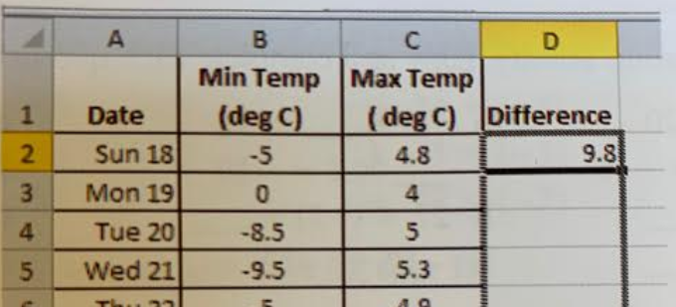

To find the difference between the maximum and minimum temperatures for Sunday 18, enter the formula =C2-B2 in cell D2. Copy this formula into cells D3 to D15. Submit a screen shot of this.

Use this information to answer the questions below

- On which day was the largest difference between the maximum and minimum recorded?

- On which day was the smallest difference recorded?

Marking
1 mark | Column added with all differences calculated
1 mark | Part a) correctly identified
1 mark | Part b) correctly identified

Average Temperatures (2 marks)

Go to http://www.bom.gov.au/climate/averages/tables/ca_nsw_names.shtml and find your hometown. Create a table showing the mean (average) maximum and minimum temperatures for each month of the year.
Marking
2 marks | Table created with maximum and minimums for each month

New York (3 marks)

Research the average maximum and minimum temperatures for New York for each month of the year. Create a table displaying this information. Compare these temperatures with that of your hometown (from question 27).
Marking
3 marks | Table created showing the maximum and minimum temperatures for each month. At least three comparisons with town from Q27 made.
2 marks | Table created showing the maximum and minimum temperatures for each month. One or two comparisons with town from Q27 made.
1 mark | Table created showing the maximum and minimum temperatures with no comparisons made.

PowerPoint (3 marks)

Create a PowerPoint that can be used to teach others one mathematical concept that you have learnt this year. This PowerPoint must be a minimum of 5 slides.

Submit a copy of this PowerPoint with your assignment.

Marking
3 marks | The PowerPoint is comprehensive and accurately teaches the concept. It contains at least 5 slides.
2 marks | The PowerPoint teaches the concept. Some information may be missing or it is only 4 slides.
1 mark | The PowerPoint is missing important information and is less than 5 slides.

Compare Number Systems (5 marks)

Research the difference between the Babylonian Number System and today's Hindu-Arabic Number System. Use the URL below to understand how the Babylonian System works.

​ https://www.basic-mathematics.com/babylonian-numeration-system.html

You need to research the answers to the questions below using multiple websites. Present your answers neatly on a separate piece of paper.

- When was the Babylonian Number System first developed?
- What is the 'base' number in the Babylonian Number System?
- Draw the number 23 using Babylonian symbols.
- In your opinion, why is the Hindu-Arabic Number System commonly used today and not Babylonian?

Marking
1 mark | Part a) Correct answer
1 mark | Part b) Correct answer
1 mark | Part c) Correct drawing of the number 23
2 marks | Part d) Answer includes at least two reasons

Overall marking comments

