Name:

Year 12 Mathematics Standard 1
Assessment Task 1

Budgeting and Household Expenses; Simultaneous Equations; Bivariate Data
Task Number: 1 |  | Weighting: 20% | Due Date: 23/11/22
Outcomes assessed:
MS11-5 MS1-12-2 MS1-12-5 MS1-12-6 MS1-12-10 | models relevant financial situations using appropriate tools  analyses representations of data in order to make predictions and draw conclusions makes informed decisions about financial situations likely to be encountered post-school represents the relationships between changing quantities in algebraic and graphical forms  uses mathematical argument and reasoning to evaluate conclusions, communicating a position clearly to others
Nature and description of the task:
As a result of completing this Assignment, students should be familiar with:
- interpreting about the costs from house bills, planning the purchase of a car, determining the cost of repayments and total amount repaid on a loan, motor vehicle insurance, calculating the cost of stamp duty, calculating the fuel consumption and running costs of a vehicle, preparing a personal budget for a given income, taking into account expenses.

- graphing and interpreting linear functions and models, applying graphical methods to solve simultaneous equations, solving simultaneous equation models and applying break-even analysis.

- constructing bivariate scatterplots to identify patterns in data, determining features and associations of bivariate datasets, identifying the dependent and independent variables, quantifying the strength of a linear association of a sample, modeling a linear association by fitting an appropriate line of best fit to a scatterplot to make predictions by either interpolation or extrapolation, implementing the statistical investigation.

On the 23rd November 2022 you will receive a selection of questions similar to those in this preparation activity booklet. You will have 50 minutes (one period) to complete in an in-class Validation Task. You are expected to investigate/attempt each of these questions in this Preparation Task before the in-class Validation Task. Solutions to the Preparation Task have been provided for you.
The final mark for this assessment will be the mark you receive on the in-class Validation Task only. Note: You will NOT have access to the Preparation Activity during the Validation Task.
Non-Completion of Task:
If you know you are going to be away on the day the Assessment Task is due and are unable to hand in Assignment on the due day, then you must have supportive documentation. Zero marks will apply if the Assessment Task is submitted/completed late, unless an Illness/ Misadventure or Application for Extension form has been submitted.

Blank Page

Preparation Activity

Section I - Multiple Choice

- A gas bill is increased by 5.8%. The previous bill was $680. What is the new gas bill correct to the nearest dollar?

(A) $39
(B) $394
(C) $686
(D) $719

- In the equation

  - ¹ 2

  - − 1 2
𝑦 =
¹ 𝑥 − 4,
2
the y-intercept is:

  - 4
  - -4

- What is the best description between living standards and life expectancy?

  - Zero correlation
  - Constant correlation
  - Negative correlation
  - Positive correlation

- Bella’s height, ℎ, over the first 20 years of her life can be modelled by the formula: ℎ = 5.5𝑎 + 68 where 𝑎 is her age in years.

At what age did Bella’s height reach 101 cm?

(A) 5.5
(B) 6
(C) 6.5
(D) 7

- What is the correlation between the variables in the scatterplot?

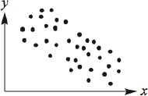
  - Strong Positive
  - Weak Positive
  - Strong Negative
  - Weak Negative

- What are the total repayments on a car purchased for $63 800 with weekly repayments of $572 for 3 years.

(A) $1 716
(B) $25 432
(C) $89 232
(D) $153 032

- Chloe’s car uses 8 L/100 km. How far can it travel on 20 L of fuel?

  - 80 km
  - 160 km
  - 200 km
  - 250 km

- A used car with a sale price of $16 500 is purchased on a 25% deposit and weekly repayments of $130 for 4 years. What is the cost of purchasing the car?

(A) $10 885
(B) $16 500
(C) $27 040
(D) $31 165

- Determine the linear function for this table of values.

𝑥 | 11 | 20 | 32 | 44 | 60
𝑦 | 27 | 45 | 69 | 93 | 125

(A) 𝑦 = 3𝑥 − 6
(B) 𝑦 = 2𝑥 + 5
(C) 𝑦 = 2𝑥 + 11
(D) 𝑦 = 3𝑥 − 15

- Which of the following best describes the correlation between 𝑥 and 𝑦 in the scatterplot shown?

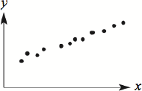
  - Strong Positive
  - Moderate Positive
  - Strong Negative
  - Moderate Negative

- Callum has been quoted $810 for comprehensive car insurance. He has a no claim bonus of 40%. How much is Callum required to pay?

(A) $324
(B) $486
(C) $1350
(D) $2025

- Peter’s Pies makes and sells gourmet pies. There is a fixed cost per day of $220 and each pie costs $2.60 to produce. The pies are sold for $6 each. Which equation represents the cost for Peter’s Pies where C represents cost and n represents the number of pies.

(A) 𝐶 = 220𝑛 + 2.60
(B) 𝐶 = 2.60𝑛 + 220
(C) 𝐶 = 2.60𝑛 + 6
(D) 𝐶 = 6𝑛 − 2.60

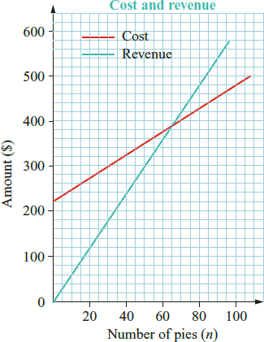
- The graph opposite shows the cost and revenue (income) for Peter’s Pies.

How many pies must be sold to break even?

  - 60
  - 62
  - 65
  - 70

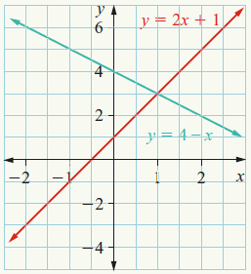
- Use the graph opposite to determine the solution to the simultaneous equations: 𝑦 = 2𝑥 + 1 and 𝑦 = 4 − 𝑥

(A) 𝑥 = 3, 𝑦 = 2
(B) 𝑥 = 3, 𝑦 = 1
(C) 𝑥 = 1, 𝑦 = 3
(D) 𝑦 = 1, 𝑦 = 4

- A new SUV is bought for $40 850. What is the stamp duty payable if the charge is $5 per $200 or part $200?

(A) $1021.25
(B) $1025 (C) $2042.50
(D) $2050

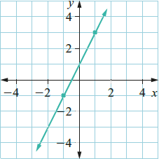
- The line opposite has a gradient of:

  - 4
  - 2
  - -4
  - -2

- Engine oil costs $65 for 5 litres. A car needs 5 litres of oil changed every 7500 km. Ian travels 30,000 km each year. What is the total cost of engine oil per year?

(A) $20
(B) $195
(C) $260
(D) $325

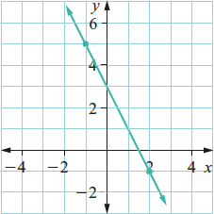
- The line opposite has the linear equation:

(A) 𝑦 = −2𝑥 + 3
(B) 𝑦 = 2𝑥 + 3
(C) 𝑦 = −3𝑥 + 3
(D) 𝑦 = −3𝑥 + 2

END OF SECTION I

Section II – Short Answer Questions

Budgeting & Household Expenses

- Jason and his family received a yearly gas bill which outlined how much they were charged each month for the previous year.
GAS USAGE MONTHLY COST
80
70
60
50
40
30
20
10
0
59.89
67.41 66.28 62.15
56.45
39.86 38.75
32.78 31.45
46.23
47.26
38.49
Month
Dollars ($AUD)

- What was the month cost for gas during November?

- What percentage of the total cost was charged in the month of July?

- Bridgette purchased a small SUV for $31 990.

She was offered two finance options, one by bank and one by the car dealership. The bank requires monthly repayments of $938.37 for 3 years while the dealership requires monthly repayments of $661.13 for 4 years.

Which finance deal is the best value for money and how much will it be?

- Emily is a mature aged student who works casually and studies full time.

Emily receives AusStudy support which amounts to $586 per fortnight and earns $225 per week working her casual job.

- Emily has set herself a maximum rent amount of 25% of her weekly income. What is her budget for rent?

- Emily has a typical weekly food spend of $110 and weekly fuel cost of $70. What is the remaining amount of money Emily has for utilities, entertainment, and medical expenses?

- Jillian is 24 and has comprehensive car insurance for her vehicle. Her premium is $1287.50 and she is able to receive a 25% no claim bonus.

The comprehensive insurance cost is set to decrease by 30% when she turns 25 and the no claim bonus will be increased to 40%.

- What is the current cost of Jillian’s comprehensive car insurance with the no-claim bonus included?

- What is the cost of the comprehensive car insurance when Jillian turns 25 before the no claim bonus is applied?

- What is the premium Jillian has to pay when she turns 25, including the no-claim bonus?

- Jonathan is moving to Australia for three years and will require a car during this time.

He is deciding between whether to lease a vehicle or purchase a vehicle for the duration of his stay. Using the figures shown, suggest which might be the best option for Jonathan and why.
This is given that he will be able to sell the vehicle at the end of the three years for 40% of its new price, if he decides to purchase one.

Costs | Leased Vehicle  Costs Per Year | Purchased Vehicle  Costs Per Year
Vehicle Repayments (0% interest) | $12 000 | $7200
Maintenance | Included | $400
Fuel | Included | $3100
Comprehensive Insurance | Included | $954
Registration | Included | $833

- A vehicle using unleaded petrol uses 7 litres of fuel when 100 km is travelled. If each litre of unleaded petrol costs 241 cents per litre, calculate how much it will cost fill an entire tank that lasts for 800 km on average. Round your answer to the nearest dollar.
Section II (
Continued)

- Luke is purchasing a new car from a dealership. They are running a deal on comprehensive car insurance if stamp duty is completed using their dealership.

Stamp duty is 4% and the car will cost Luke $27 650.

- Calculate the stamp duty Luke will have to pay.

- Calculate the savings on comprehensive insurance, if it is 25% off and the original premium is $986.

- Calculate the amount Luke must pay to the dealership in insurance and stamp duty.

Simultaneous Equations

- For the linear equation 𝑦 = 5 − 2𝑥
- Complete the table of values below.

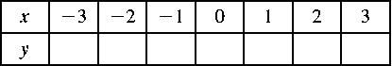

- Graph the line on a number plane.

- State the gradient and the y-intercept of the following lines.
a. 𝑦 = 2𝑥 + 7

b. 𝑦 = − 2
3
𝑥 − 5

c. 4𝑥 + 2𝑦 = 1

- Write the equation of the line below.
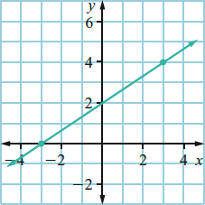

- The distance, d kilometres, travelled by a train in a time of t hours is 𝑑 = 80𝑡.

- Draw a graph of the linear model 𝑑 = 80𝑡.

- Where does this graph cut the vertical axis? Why?

- What is the gradient of the line? What does this value represent in this model?

- Use the graph to find how far away the train is after 3.5 hours.

- Use the graph to find when the train is 200 km away.

- Consider the following pair of simultaneous linear equations and their graphs drawn on the same number plane.

𝑦 = 𝑥 − 7 and 𝑦 = −3𝑥 + 9

- Write the coordinates of the point of intersection of the two lines.

- Use the coordinates of this point to write the solution to the simultaneous linear equations.

- The cost of hiring a car from company A is $50 per day. Alternatively, Company B charges a fee of $60 plus $40 per day the car is hired.

- Write an equation to represent the cost ($C) of hiring a car from Company A per day (d).

- Write an equation to represent the cost ($C) of hiring a car from Company B per day (d).

- Graph the equations on the same set of axes and solve simultaneously.

- After how many days is it cheaper to hire from Company B?

- The graph below shows the income and cost of making and selling sushi rolls.

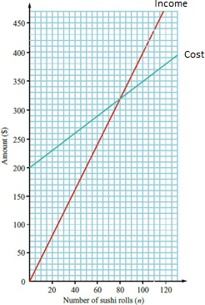

- How many sushi rolls must be sold to break even?

- How much profit or loss is made when 100 sushi rolls are sold?

Bivariate Data Analysis

- The data below shows the cost of fuel (per litre), and the average number of people on trains per day (in 1000’s).

Cost of Fuel | $1.20 | $1.30 | $1.40 | $1.50 | $1.60 | $1.70
No. of Commuters | 823 | 812 | 801 | 762 | 721 | 691

- Construct a scatterplot using the data above.

- Is there a relationship between the two variables? If so, describe the strength and direction of the association.

- There is a high negative correlation between number of answers per question available on a multiple-choice test and the number of questions answered correctly. Give one reason why this correlation may exist.

- There is a strong positive correlation between the weight of a car and the litres per kilometre it consumes. State the independent and dependent variable in this situation.

- The scatterplot shows the English and Mathematics results for 20 students.
Test Scores
21
20
19
18
17
16
15
14
13
12
11
10
9
8
7
6
5
4
3
2
1
0
0 1 2 3 4 5 6 7 8 9 10 11 12 13 14 15 16 17 18 19 20
English Scores
Maths Scores

- How many students do better in Mathematics than English?

- Is there any correlation between high English results and Mathematics results?

- What is the highest combined Mathematics and English score?

- The table below shows the number of rebounds per game for 10 people who play different amounts of minutes in a basketball game.

Minutes  Played (x) | 4 | 8 | 12 | 16 | 20 | 24 | 28 | 32 | 36 | 40
Rebounds Grabbed  (y) | 2 | 3 | 5 | 6 | 7 | 9 | 12 | 15 | 17 | 18

- Draw a scatterplot using minutes played as the horizontal axis and rebounds grabbed as the vertical axis.

- Draw a line of best fit and calculate the equation of this line in the form 𝑦 = 𝑚𝑥 + 𝑐.

- Use your equation to predict the number of rebounds grabbed when a player plays for 38 minutes.

- Use the equation to predict the minutes played if a player grabs 11 rebounds.

End of Preparation Activity

Solutions

Multiple Choice

- D  - D  - D  - B  - D  - C  - D  - D  - B  - A | - B  - B  - C  - C  - A  - B  - C  - A

Short Answer

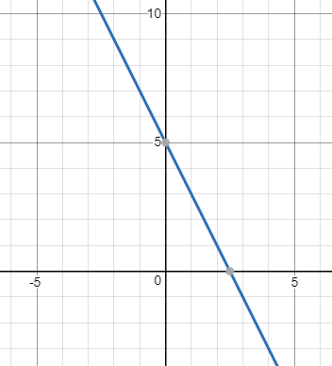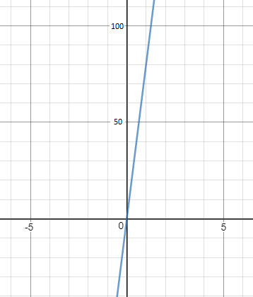19. a. $47.26 b. 10%

28.

𝑦 =

² 𝑥 + 2
3

- Dealership is best at $31 734.24

- a. $129.50 b. $338 (not including rent) 22. a. $965.63 b. $901.25 c. $540.75
23. Best value to purchase the car as the final cost is
$9 607 whereas hiring is a total cost of $12 000. 24. $135
25. a. $1 106 b. $246.50 c. $1 352.50

26. a. Table of Values
𝑥 | -3 | -2 | -1 | 0 | 1 | 2 | 3
𝑦 | 11 | 9 | 7 | 5 | 3 | 1 | -1

b.

29. a.

  - Zero – no time taken, no distance travelled
  - Gradient = 80, 80 km in each hour travelled
  - 280 km
  - 2.5 hours

30. a. (4, -3) b. 𝑥 = 4, 𝑦 = −3

27. a. 𝑚 = 2, 𝑏 = 7 b.
c. 𝑚 = −2, 𝑏 = 1
2
𝑚 = − 2
3
, 𝑏 = −3

31. a. 𝐶 = 50𝑑 b. 𝐶 = 40𝑑 + 60  c.  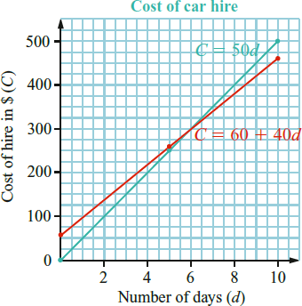  d. 5 days  - a. 80 rolls b. $50 profit  - a.  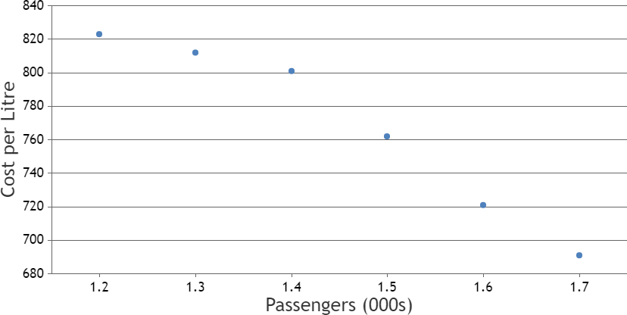  b. Linear, negative, strong association | - Less chance of simply guessing correct answer due to more variables.  - Independent = Weight of vehicle Dependent = Litres per kilometre consumed  - a. 7 b. Linear, positive, weak  c. 35 total marks  - a.  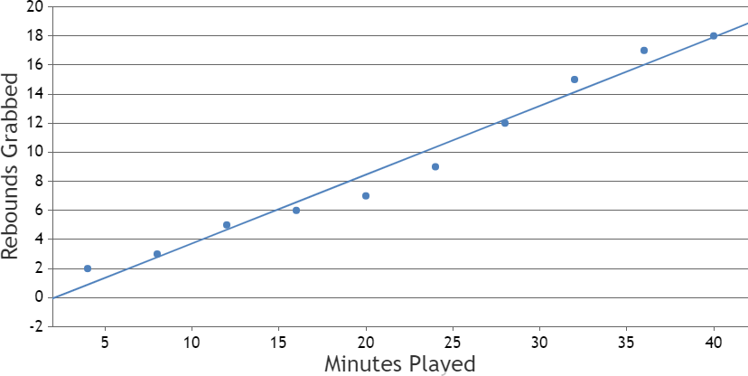  b. 𝑦 = 4𝑥 + 0 c. 17 rebounds d. 25 mins

