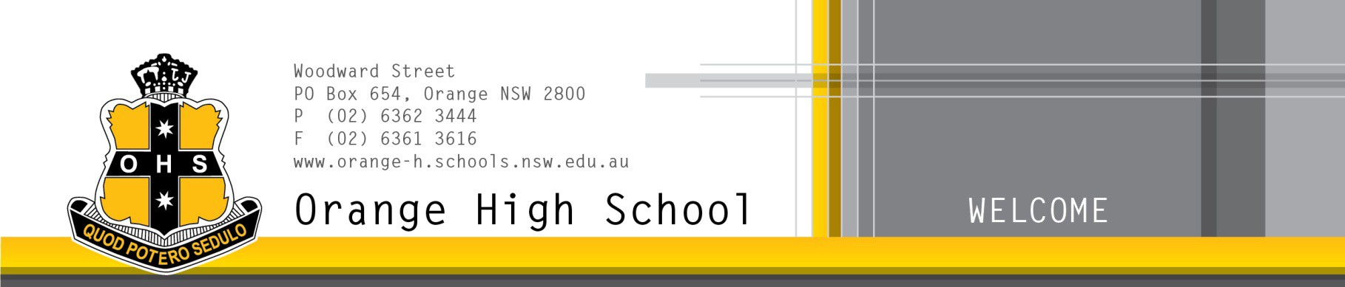
Achievement in a supportive environment

Special Religious Education Participation Letter

A feature of the public education system in NSW is the opportunity to provide time in class for religious education at the choice of parents/carers.

The school website https://orange-h.schools.nsw.gov.au provides information on these options to support parent/carer choice. For more information about Special Religious Education (SRE) including the list of approved providers, please visit: https://education.nsw.gov.au/teaching-and- learning/curriculum/learning-across-the-curriculum/religion-and-ethics

If your child does not participate in SRE they will undertake supervised alternative meaningful activities during this time.

A parent/carer may at any time notify the school in writing that they wish to change their decision. Students will continue the same arrangement from Years 7 to 10, unless a parent/carer requests a change in writing.

At Orange High School, SRE is provided by Fusion Australia.

If you would like your child to attend, please sign below and return the permission slip below to our school.

Participation Letter

I give permission for my child, (student name) ________Year: _____

to attend SRE at Orange High School.

Signature of parent/carer: _Date:

